HHPD PAC 06
Fall 05

Peripheral Vascular System

Bates’ Chapter 14

Introduction

The peripheral vascular system consists of the arteries, veins the lymphatic system

that supply the upper and lower extremities.

Anatomy and location of:

Peripheral arteries:

- Pulses from arteries are palpable when location is superficial

- Upper extremity

  - Brachial, radial, ulnar

- Lower extremity

  - Femoral, popliteal, dorsalis pedis, posterior tibialis

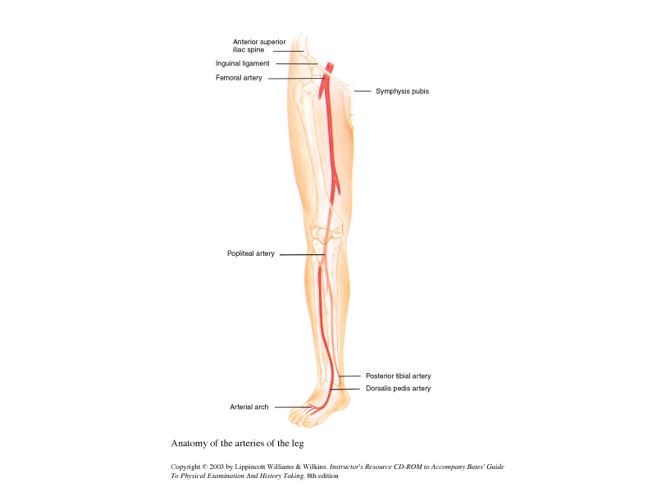

Peripheral veins:

- Veins from the head and neck, trunk and upper extremities drain into the Superior Vena Cava

- Veins from the lower trunk and legs drain upward to the Inferior Vena Cava

  - Deep veins
    - Carry 90% of the venous return from the lower extremities
    - They are supported by surrounding tissues (muscles)

  - Superficial veins
    - Are subcutaneous
    - Have poor support
    - Examples:
      - Great saphenous vein meets the femoral vein (deep venous system) below inguinal ligament

      - Small saphenous vein runs along the back of the leg and joins the deep venous system at the popliteal space

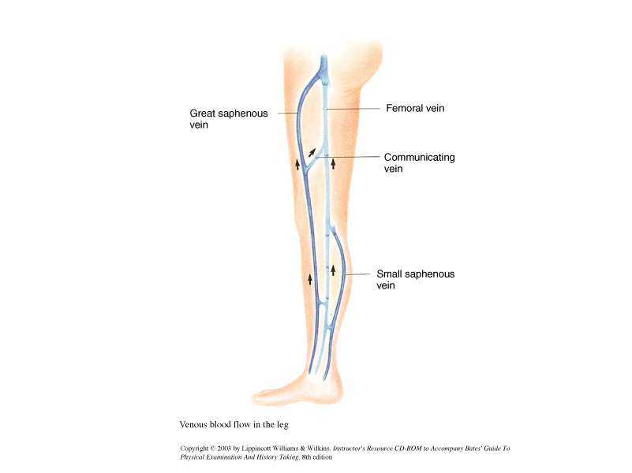

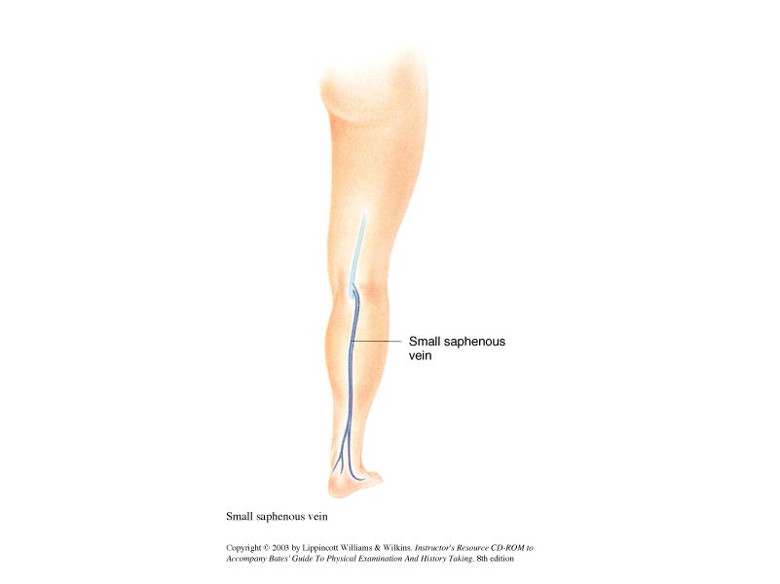

- One-way valve venous system

  - All veins, deep, superficial and communicating, have one-way valves, which prevent backflow of blood and facilitate blood to flow from the superficial to the deep venous system and on to the heart.

    - Supporting structures include muscles from the calf, which contract with walking therefore promoting forward movement of the blood against gravity.

Lower Extremity Varicosities
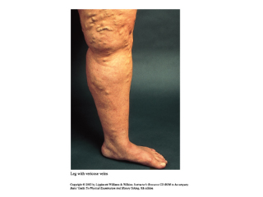

    - The Lymphatic System
- The main function of the lymphatic system is to provide an accessory circulatory system where interstitial (protein containing cellular waste products) fluid can flow from the interstitial spaces and into the blood.

  - 10% of the interstitial fluid enters the lymphatic capillaries and returns to the blood via the lymphatic system

- The Lymphatic system starts peripherally as a network of blind-ended capillary vessels and nodes that transport the lymph throughout the body.

  - Blind-ended vessels: there is no heart pumping the lymph fluid as in blood circulation—it relies on it being squeezed by our muscles as we move.
  - Lymph is transported from the capillaries to lymphatic collecting ducts that drain into the venous system

  - Major lymph channels:

- All lymph from the lower part of the body flows up the thoracic duct and empties into the venous system. The left side of the head, arm and left chest flows also empties into the thoracic duct.
- Lymph from the right side of the head and neck, arm and thorax enters the right lymph duct

- Lymph is also know as “the other blood”—it is collected from tissues throughout the body; flows through the lymphatic system—through the lymph nodes—and eventually returns to the circulation via the venous system.

  - In capillary beds blood components—such as lymph— squeezes through small capillary spaces carrying nutrients to the cells. Nutrients are exchanged for dissolved CO2 and other nitrogenous waste products. Then the lymph is directed back to the vessels and towards the venous circulation. Waste is removed by the renal and hepatic systems.

  - It also transports lymphocytes and other WBCs (macrophages) throughout the body.

- Lymph nodes are nodules within lymph vessels that produce lymphocytes. Lymph nodes also filters lymph fluid

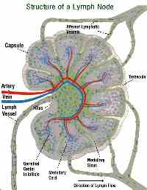

  - Lymph nodes are grouped in different parts of the body.
  - They respond to infection, tissue trauma and inflammation by increasing lymphocyte production
  - Typically they are round or oval and measure up to 1cm or up to 2cm in some cases

    - Usually larger relative to body size in children and young adults

- Clinically Important Anatomical Locations

  - Upper Extremity

    - Maxillary
      - Central
      - Lateral
      - Posterior
      - Anterior
    - Epitrochlear
      - Drains into the axillary and infraclavicular
      - Ulnar, ring finger, middle finger
      - Ulnar surface of hand and arm

- Infraclavicular

- Lower Extremity

- Superficial inguinal nodes

      - Horizontal group
    - Below inguinal ligament
    - Drains superficial portion of:

      - Lower abdomen
      - Buttock
      - External genitalia (except testes)
      - Anal canal and Perianal area
      - Lower vagina

  - Vertical group
    - Clusters near the upper part of the Saphenous vein

    - Drains that area of the upper thigh

    - Calf, heel and outer aspect of the foot are drained by deeper lymphatic system not accessible to examination

Lymphatic Drainage of the Upper Extremity

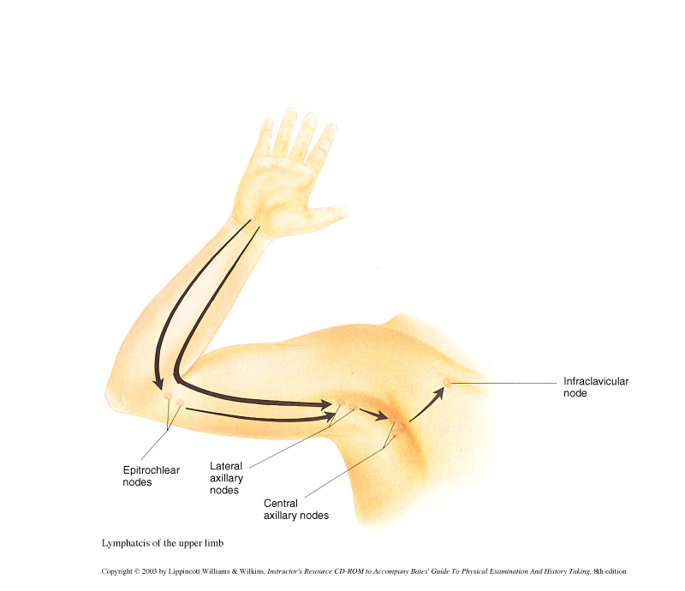

Lymphatic Drainage of the Lower Extremities
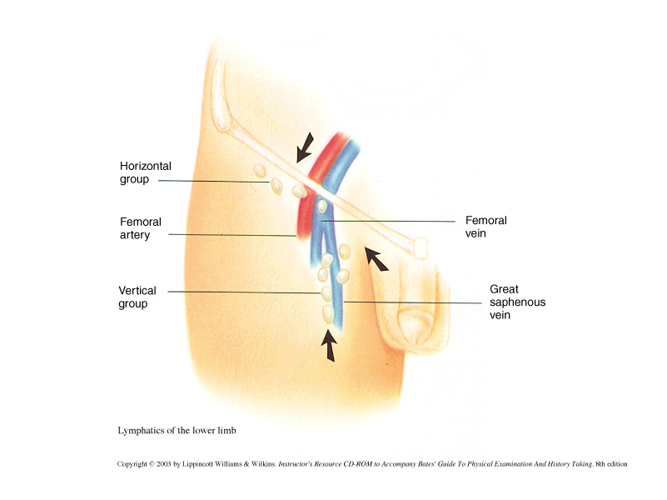
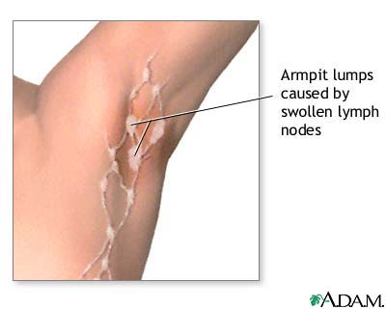

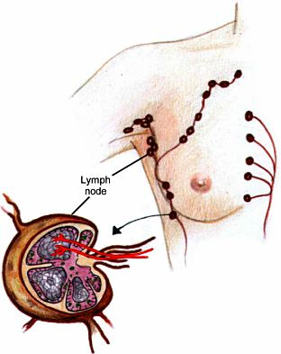

Fluid exchange in the capillary bed

(Understanding Edema)

- Pathophysiology:

  - Blood flows from arteries to veins by passing through capillary beds

- Fluid diffuses across the capillary membrane—through capillary spaces—and the interstitial spaces. Blood pressure (hydrostatic pressure) forces fluid out of the arteriolar end and into the interstitial spaces. Weak osmotic interstitial pressure aides the movement of blood lymph

- Blood continues to flow towards the venous end of the capillary bed and as the hydrostatic pressure falls interstitial osmotic pressure overcomes hydrostatic pressure and pulls intercellular lymph into the venous system.

- Lymphatic capillaries absorb up to 10% of fluid from the interstitial space.

Fluid Exchange in the Capillary Bed

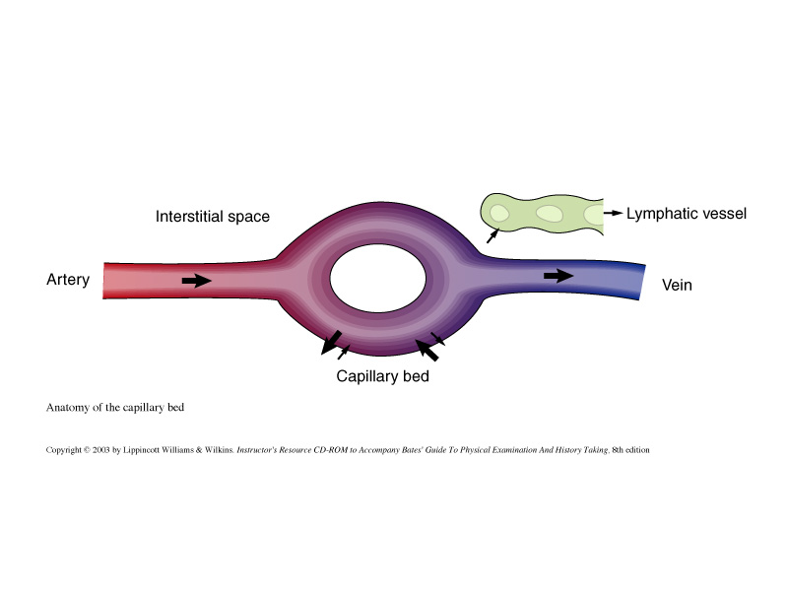

- Clinical Implications

  - Lymphatic dysfunction creating disturbances in hydrostatic or osmotic pressure can disrupt the equilibrium between the intravasular and interstitial spaces.
- Hypertension, fluid overload, renal failure can increase the arterial end pressure in the capillary bed—resulting in edema
  - Right sided or right and left ventricular failure, hepatic venous obstruction, renal failure can increase the venous end pressure in the capillary bed—resulting in edema

    - Edema is the most common clinical result of increased interstitial fluid accumulation

Pedal Edema?

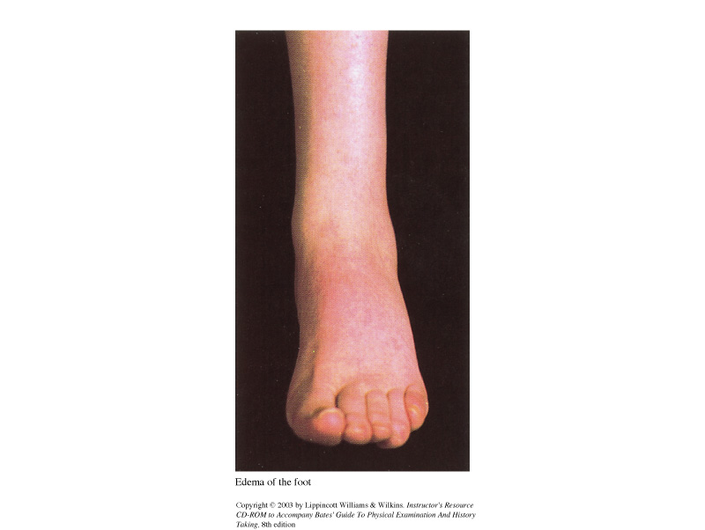

Assessing for Pitting Edema

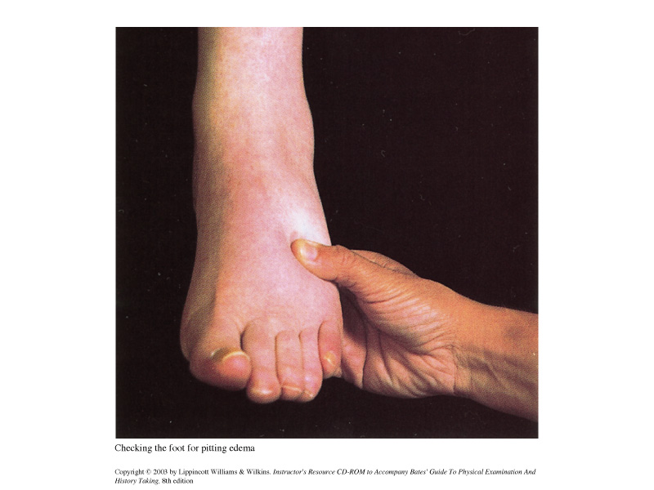

Pitting Pedal Edema

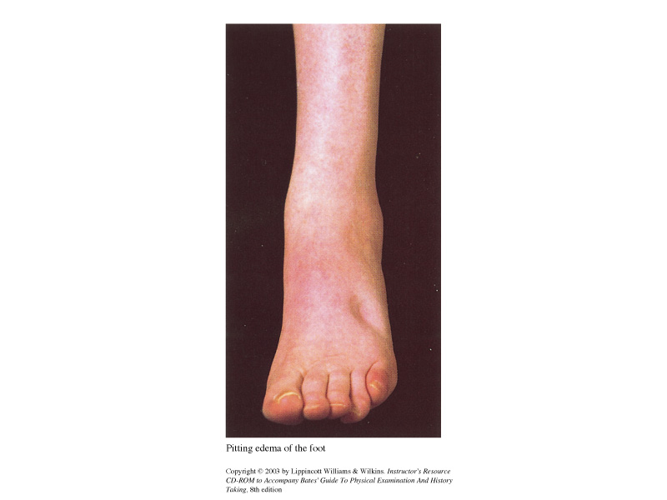

Clinical Points to Consider:

- Age lengthens the arteries and veins—making them tortuous. Vessels walls stiffen. These changes are not clinically significant
- Loss of arterial pulsations are clinically significant and must be evaluated
- Skin changes also occur with the aging process

- Becomes thin and dry
- Nails grow more slowly
- Hairs on legs become more scant
- These changes can occur with arterial insufficiency as well

Techniques of Examination:

- Inspection of upper extremities
  - Arms
    - Inspect both arms from the fingertips to the shoulders
      - Symmetry
      - Size
      - Swelling
      - Venous pattern
      - Color of skin and nail beds
      - Skin texture
      - Palpate the radial pulse

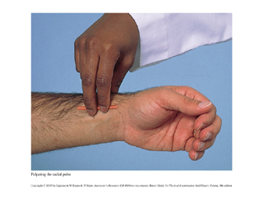Palpating the radial pulse

        - Grading of pulses:
          - 0=absent
          - 1=diminished
          - 2=normal
          - 3=increased
- 4=bounding

        - Compare pulses in both arms
        - Describe pulses as:
          - Increased
          - Normal
          - Diminished
          - Absent
          - Aneurysmal

            - If there is arterial insufficiency palpate the
Brachial/ulnar artery

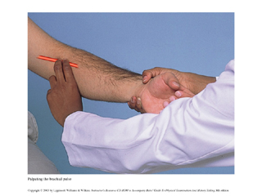Palpating the brachial pulse

- Palpate the Epitrochlear nodes
  - Located about 3cm above medial epicondyle
  - Note:
    - Size
    - Consistency
    - Tenderness
    - Usually difficult to palpate in most people

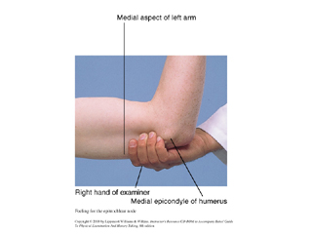Palpating the epitrochlear nodes

- Legs
- The patient should be lying down and the external genitalia covered and legs/feet fully exposed
  - Inspect
    - Both legs from groin to feet
    - Note:
      - Size
      - Symmetry
      - Swelling
      - Venous pattern and enlargement
      - Pigmentation, rashes, scars, ulcers
      - Color and texture of skin
      - Color of nail beds
      - Distribution of hair on the lower legs, feet, toes

  - Palpate
  - Superficial Inguinal Nodes
    - Horizontal and Vertical
    - Note:
      - Size
      - Consistency
      - Discreteness
      - Tenderness
      - Nontender, discrete inguinal nodes up to 1cm to 2cm are normal

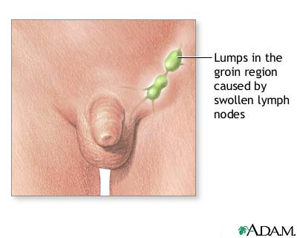

Lymphogranuloma Venereum (Chlamydia trachomatis)—What lymphatic chain is affected?
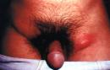

Other Structures to Examine:

  - Femoral Pulses
    - Press deeply
    - Use of two hands can facilitate palpation
    - Popliteal Pulses
      - Flex patient’s knee
      - Palpate deep with fingers into the popliteal fossa
      - May need to ask pt to change to prone position if pulse cannot be felt

  - Dorsalis Pedis Pulses
    - Dorsum of foot lateral to extensor tendon of great toe
    - Explore more laterally if you cannot feel it
  - Posterior Tibialis Pulses
    - Behind medial Malleous
    - May be difficult to palpate with edema or fat
  - Popliteal Pulse

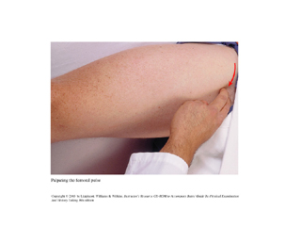Palpation of Femoral Pulse

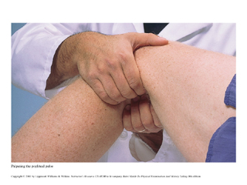Palpation of the popliteal pulse
Palpation of Popliteal Pulse in the “Prone” position

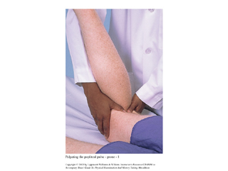

Dorsalis Pedis Pulse

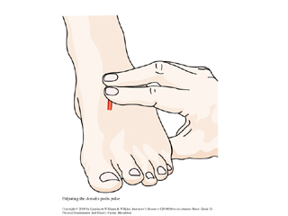

Posterior Tibial Pulse

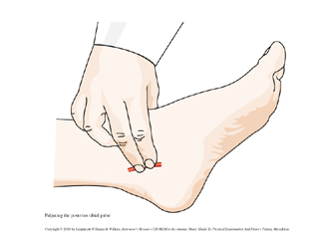

  - Assess for extremity temperature

    - Note temperature of feet and legs with the BACK of your fingers
    - Compare one side with the other
    - Bilateral vs. unilateral coldness

  - Assess for extremity edema (Anasarca)
    - Compare size, prominence of veins, tendons and bones
    - Check for PITTING edema
      - Press over dorsum, medial malleous, shins for 5 seconds
        - Look for indentation or depression
          - Normally there should be none
      - If there is pitting edema:
        - Grade from 1-4 (slight to very marked)
        - Measure forefoot, ankle, largest circumference at the calf and midthigh (measured distance from the patella) and compare one side with the other
          - 1cm above ankle and 2cm at the calf is abnormal
        - How far up does the swelling go?
        - Is it uni or bilateral?
        - Are the veins prominent?
          - Venous cause of edema
        - Is there tenderness?
          - Could be DVT
          - Palpate:
            - Femoral vein
            - Calf with patient’s leg flexed at the knee and relaxed
            - Gently compress calf muscles against tibia and search for tenderness or cords
            - DVT may not have any cords

- Implications
  - Look for causes:
    - Deep Vein Thrombosis (DVT)
      - Calf=lower leg/ankle swelling
      - Iliofemoral veins=entire leg is swollen
    - Chronic venous insufficiency due to previous DVT or incompetent vein valves
    - Lymphedema
      - Lymphatic system obstruction

- Note Color of Skin

- Is there local redness?

- If there is feel for cord

- Note temperature

- Are there brownish areas near the ankles?

- Are there any ulcers? Note locations

- Feel the thickness of the skin

- Ask patient to stand (assessing venous pooling)
  - Inspect saphenous system for varicosities
    - Palpate for thrombophlebitis

The Allen Test

- Palpating for arterial insufficiency in the hand
  - With hand on lap ask patient to squeeze hand
  - Compress both ulnar and radial pulses
  - Ask patient to relax hand—should be pale
  - Release pressure from ulnar/radial artery
  - Palm should flush in 3-5seconds
  - Persistent pallor indicates arterial occlusion

- Must use this test prior to radial artery puncture

The Allen Test
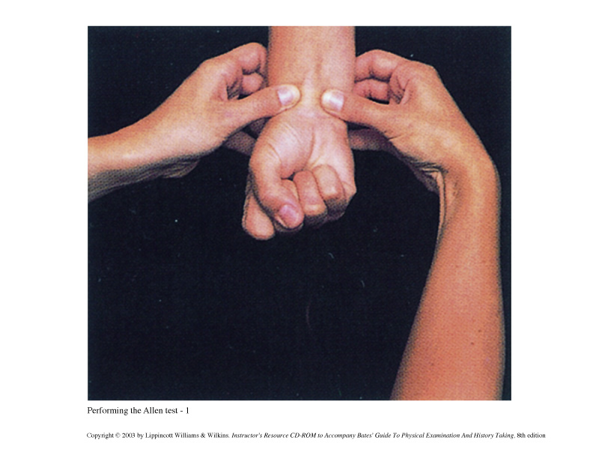

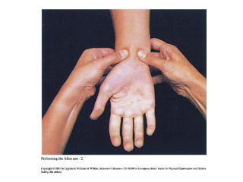

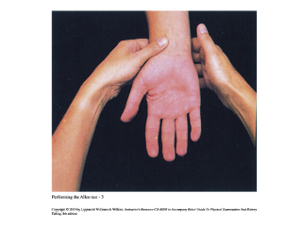
Persisting Pallor—Indicative of Arterial Obstruction

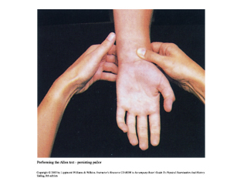

Postural Color Changes of Chronic Arterial Insufficiency

- Raise both legs until pallor develops—compare degree of pallor
- Ask pt to let legs down—compare filling of veins and flushing

Arterial Insufficiency

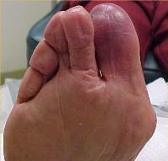

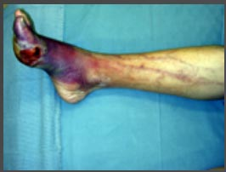Peripheral Vascular Disease--Advanced

Homan’s Sign:
- Knee slightly flexed—provider dorsiflexes forefoot
  - This maneuver is used in suspected DVT
  - Not very reliable but MUST be done

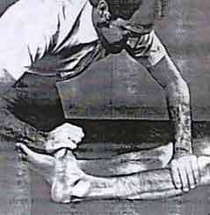

Clinical Considerations:

DVT can lead to pulmonary emboli: 40% of untreated PEs are fatal. 175,000 deaths are attributed to acute PE.

Intermittent claudication is the symptom of pain in the lower extremity during exercise when there is arterial ischemia. Peripheral artery disease is caused by arteriosclerosis, which is characterized by lipid deposits in the intima causing fibrosis and calcification. In addition, high blood pressure, smoking, free radicals, causes damage to the cells lining the intima. Collateral blood vessels take up the role of supplying blood to that part of the body. When exercise increases O2 demand collaterals circulation may not be sufficient to supply needed O2 demand.

Symptoms of arterial vascular disease: Health History Issues

- Pain (most common) during exercise
- poikilothermic
- The site of pain is always DISTAL to the occlusion
- Can involve buttock, hips, thighs, arch of foot, and especially the calf
- Pain is aggravated by cool temperatures and elevation
- Pain also occurs with DVT
- Changes in skin temperature and color (cool and pale)
- Erectile dysfunction (in male patients c/o buttock or thigh pain)=LERICHE’S Syndrome=Aortoiliac obstruction
- Ulcers and gangrenous skin changes
- These ulcers progress rapidly
- The seven Ps: pallor, pain, paresthesias, pulselessness, paralysis, poikilothermy (polar), pistol shot pain

Symptoms of venous insufficiency: Health History Issues

- Warmer than normal extremity
- Edema
- Ulcers are painless and occur in the ankle area (are due to trauma-does not have to be major trauma—even mild trauma can cause a serious ulcer to form)
- Venous stasis ulcers are slow growing
- Increased pigmentation due to venous stasis and swelling

- Lymphedema vs. Edema

- Pitting vs. nonpitting edema

Chronic Venous Insufficiency

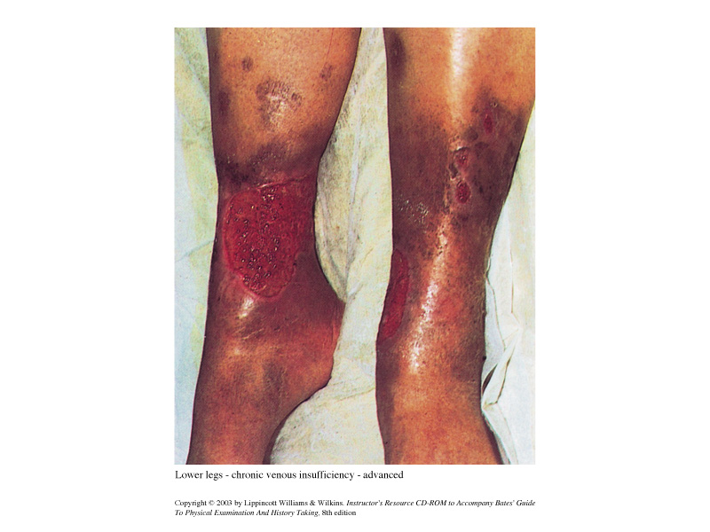

Arterial Insufficiency—lower extremity

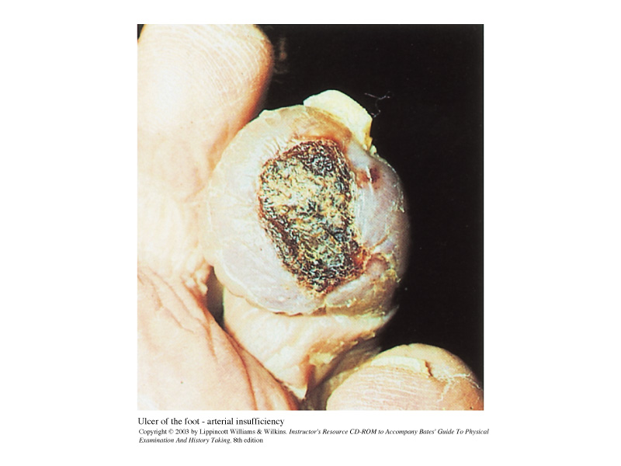

Diabetic Foot Ulcer due to poor arterial circulation/impaired O2 tissue perfusion

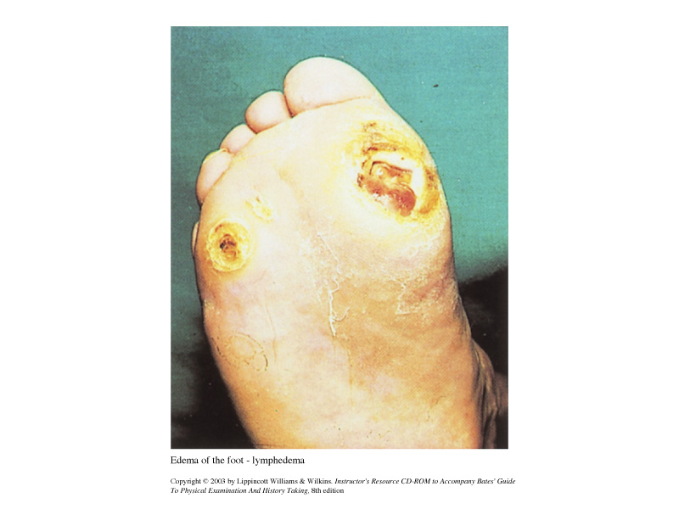

Distinguishing between Edema and Lymphadema

