HHPD PAC 06
The Cardiac Exam
Fall 2005

Basic Cardiac and Chest Anatomy and Physiology
- Anatomy review
- Anatomical location of:
- Right Ventricle and Pulmonary Artery occupies most of the Anterior Chest Wall (mostly BEHIND and to the LEFT of the STERNUM)

- The inferior boarder of the Right Ventricle lies between the junction of the Sternum and the Xiphoid Process

- The BASE of the HEART refers to the area where the Right Ventricle meets the Pulmonary Artery at the level of the 2nd INTERSPACE along the left and right STERNAL boarders

- The LEFT Ventricle sits behind the Right Ventricle. The Left Ventricle forms the LEFT LATERAL MARGIN of the heart.
- The Left Ventricular tip is called the CARDIAC APEX 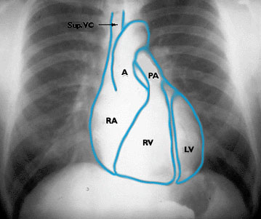
- Produces the APICAL IMPULSE or the POINT OF MAXIMAL IMPULSE=PMI
- This point locates the boarder of the Left Heart
- Located at the 5th Interspace MIDCLAVICULAR LINE
- This area is about 1-2.5 cm in diameter
- The RIGHT ATRIUM and SVC forms the heart’s RIGHT BOARDER between the 3rd and 5th ribs anteriorly
- The LEFT ATRIUM is not accessible for physical examination
- The AORTA arises from the LEFT VENTRICLE—superiorly to the PULMONARY ARTERY--@ the STERNAL ANGLE and 1ST interspace ALONG THE LEFT STERNAL BOARDER
- The SCV lies along the RIGHT STERNAL BOARDER between the 1st and 3rd ribs

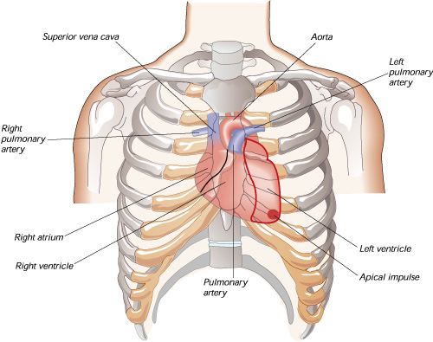

- Cardiac Structures:
- Atrioventricular Valves
- Mitral and Tricuspid valves
- Semilunar Valves
- Aortic and Pulmonic valves

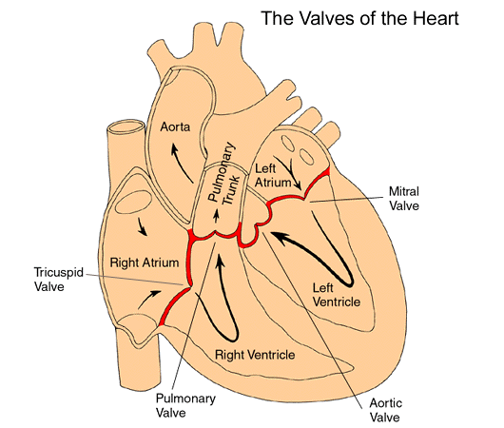
- Review course of DEOXYGENATED and OXYGENATED BLOOD through the heart and how this relates to VALVULAR movement
- Review Pressure Gradients within the Ventricles and Atriums and how high pressure causes the closure and opening of valves—Bates P. 249-250

K. C. Potger
Copyright © 2001

Events in the Cardiac Cycle:
- SYSTOLE represents ventricular contraction—maximal L ventricular pressure corresponds to SYSTEMIC SYSTOLIC BLOOD PRESSURE
- DIASTOLE represents ventricular relaxation
- The maximal Left Ventricular Pressure corresponds to Systolic Blood Pressure
- Closure of the MITRAL Valve produces the FIRST heart sound-S1--LUP
- Closure of the AORTIC Valve produces the SECOND heart sound-S2--DUP

Closure of heart valves as these relate to heart sounds and MURMURS
M1T1 A2P2 M1T1 A2P2

R S R S R S

SYSTOLE DIASTOLE SYSTOLE DIASTOLE
S1--LUP S2--DUP S1--LUP S2--DUP

- Extra heart sounds:
  - Ej –ejection murmur—early opening of aortic valve in stenosis
  - OS –opening snap DIASTOLIC sound in mitral stenosis
  - S3 –“S3 Gallop” in rapid deceleration of ventricular filling in heart failure, normally in children and young adults—heard right before S2
  - S4—“S4 Gallop” seen with VENTRICULAR FILLING RESISTANCE—in HTN, aortic stenosis, hypertrophic cardiomyopathy)
  - S3 and S4 are normal findings in athletes, but
- Splitting of HEART SOUNDS
  - Heart sounds are made up of LEFT and RIGHT Ventricular and Atrial activity.
    - Pressure on the right side of the heart is much lower than on the left.
    - Right-sided cardiac activity occur slightly later than on the Left-side
      - S1 and S2 consists of a right and left-sided heart components
        - S1=Mitral (M1) and Tricuspid (T1) Components
        - S2=Aortic (A2) and Pulmonic (P2)
        - During EXPIRATION A2 and P2 are FUSED into a single sound
        - During INSPIRATION S2 can be split SLIGHTLY and A2 and P2 can be heard as separate sounds
        - S1 can also be heard as a SPLIT S1 but splitting of S1 is not influenced with respiration—S1 splitting is harder to detect

Faster Slower

M1T1 A2P2 M1T1 A2 P2

S1 EXPIRATION S2 S1 INSPIRATION SPLIT S2

- Locating Heart Sounds and their Origins
  - S1 is heard best in the cardiac apex—why?
  - S2 is heard best at the cardiac base—why?
- Murmurs occur when there is turbulent blood flow across cardiac valves due to valvular stenosis or regurgitation/insufficiency
  - Where heart sounds or murmurs are heard on the chest wall can tell us where they originate:
    - Mitral = Cardiac Apex
    - Tricuspid = Lower Left Sternal Boarder (ICS 4,5)
    - Pulmonic = 2nd and 3rd Left Interspaces along the Sternum
    - Aortic = Right 2nd Interspace to the Apex
  - The timing (SYSTOLIC vs. DIASTOLIC) also tells us which valve is affected and what might the abnormality be (stenosis vs regurgitation)—See diagram above

Jugular Venous Pressure
- Pressure in the RIGHT INTERNAL JUGULAR veins reflects right-sided heart (right atrium) pressure or the Central Venous Pressure.

- Internal Jugular Vein lies underneath the Sternocleidomastoid muscle its pulsations are hard to visualize. We use the DISTENTION from the External Jugular Vein to approximate the Jugular Venous Distention or the JVD—but these pulsations are not as reliable as those emanating from the Internal Jugular Vein.
- To measure the Jugular Venous Pressure we need to locate its pulsations that reflect right atrial activity and measure the height of the pulsations.
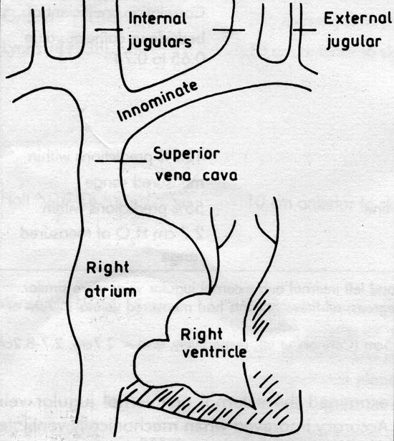

The Health History
- Common Symptoms:
- Chest Pain (Angina Pectoris, Myocardial Infarction, Dissecting Aortic Aneurysm, surrounding cardiac structures, pulmonary and extrapulmonary)
- Questions to ask:
- Do you have chest pain?
- Ask the patient to point to the site of pain
- Perform the seven symptom attribute
- Is the pain activity related?
- Do you experience pain at rest?
- What brings on the pain?
- Does it radiate?
- Are there any associated symptoms like SOB (Dyspnea), SOB on exertion (dyspnea on exertion) sweating (diaphoresis), palpitations or nausea?
- Does the pain wake you up at night?
- What makes it better?
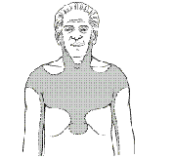
Am I Having a Heart Attack? (From Kaiser Permanente Patient Information)
You may be having a heart attack if you feel any of these symptoms:
Chest discomfort or pain that:
Lasts longer than 20 minutes AND is not relieved by rest or nitroglycerin AND feels like:
- Pressure | - Tightness | - Squeezing | Crushing
- Intense burning | - Aching
In addition to the symptom above, you may also have:
Pain radiating to your:
- Back | - Shoulder | - Neck | - Jaw/teeth
- Arm | - Wrist
As well as:
Sweating | Shortness of breath | Dizziness | Fainting
Nausea  (feeling sick to your stomach) | Vomiting (throwing up) | Unusual weakness | Rapid and/or irregular heartbeat
Sense of doom
The more boxes you check, the more likely it is that you are having a heart attack. There may be other explanations for chest pain, but it is important to get medical help immediately
The Levine Sign!


Other Symptoms:
- Palpitations
- Are you ever aware of your heartbeat?
- Was the rate fast or slow, regular or irregular?
- How long did the palpitations last?
- Shortness of breath, orthopnea, paroxysmal nocturnal dyspnea (PND)
- Do you become SOB when you exert yourself? At rest?
- Do you wake up at night with difficulty breathing? (can be associated with wheezing and or coughing)
- How many pillows do you sleep with?
- Does the SOB improve when you sit up?
- Swelling or edema
- Have you had any swelling anywhere?
- When does it occur?
- Is it worse in the morning or at night?
- Do your shoes get tight?
- Has your belt needed loosening?
- Are your eyelids swollen in the morning?

Recording the Physical Examination
- Example: Jugular Venous Pressure 1cm above the sternal angle, @ 30º. Coratids without bruits bilaterally. Apical impulse felt at the PMI @ 5th ICS/MCL. Good S1/S2. No S3 or S4. A II/VI Systolic ejection murmur heard @ the 3rd interspace along the left sternal boarder, without radiation to the neck. No diastolic murmurs.

Techniques of Examination
- Start with the BP, HR, RR
- Sequence of the CARDIAC EXAMINATION (patient positions)
- Supine, with the head elevated @ 30º
- Inspect, palpate precordium
- Left lateral Decubitus
- Palpate APICAL IMPULSE (APEX) with hand
- Supine, with the head elevated @ 30º
- Listen to all auscultatory areas with diaphragm and bell
- Sitting, leaning forward, after full exhalation
- Listen along Left sternal Boarder and at the APEX

- JUGULAR VENOUS PRESSURE (JVP)/DISTENTION (JVD)
- The pt is lying down @ a 30º angle.
- A Measurement of 3cm or more above the sternal angle is considered elevated.
- Begin at the point where the Internal Jugular vein appears to collapse. Measure the vertical distance from this point from the sternal angle.
- If the highest point of venous pulsation are seen below the level of the sternal angle JVP is not elevated and does not have to be measured.
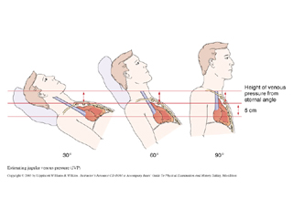

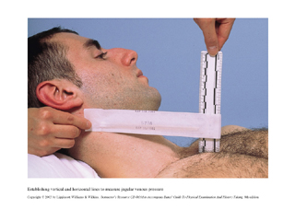

- HEPATOJUGULAR REFLUX –Understand Mechanism
- The pt is lying down @ a 30º angle.
- HJR: enables estimation of right atrial pressure
- Apply pressure in the abdominal RUQ and look for vein distention
- Do as part of the abdominal exam!

- The Carotid Pulse
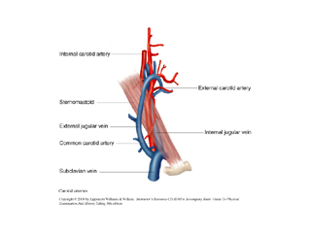
- The pt is lying down @ a 30º angle.
- Carotid pulse can be palpated just medially to the SCM muscles.
- You can use your thumb or index/middle fingers.
- AVOID pressing on the Carotid Sinus (can decrease BP and HR)
- Examine one carotid artery at a time
- Assess the AMPLITUDE (does it have a good bounce?) and CONTOUR (feel for the briskness of the upstroke—the downstroke is softer) of the Carotid pulsations.
- If you cannot assess the amplitude/contour of the carotid arteries use the Brachial Arteries instead.
- Note the rate and rhythm of the carotid pulse
- Thrills and Bruits
- Thrills: a humming vibration felt during palpation (like the Purr of a cat)
- Listen over the carotids for bruits using the diaphragm of your stethoscope (vascular in origin vs cardiac)

THE HEART

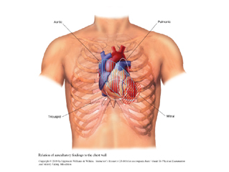

- The pt is lying down @ a 30º angle.
- Other positions to examine the patient:
- Left Lateral Decubitus
- Sitting, leaning forward, after full exhalation
- Examiner stands on the pt’s right side
- The pt will be asked to turn to his/her LEFT side and to lean forward during the exam.
- INSPECTION
- The Precordium: 2nd Interspaces, the right/left ventricle, PMI
- Inspect for HEAVES (lifts), pulsations, retractions
- PALPATION
Areas of Palpation
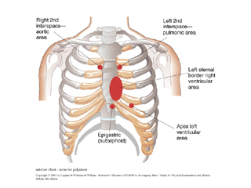

- Begin with GENERAL palpation of the chest wall using finger pads
- Palpate the:
- Aortic—2nd right ICS
- Pulmonic—2nd left ICS
- Tricuspid—3rd, 4th, 5th ICS
- Mitral (PMI, APEX) –left 5th ICS @ midclavicular line
- Right ventricular areas with the pads of your examining fingers
- Ventricular pulses (at the PMI) may lift your fingers
- Then using the BALL of your hand check for THRILLS by pressing firmly on the chest wall—ESPECIALLY OVER VALVULAR AND PMI
- PMI: Assess the quality of the PMI or Apical Impulse (left ventricular area)

Locating the PMI
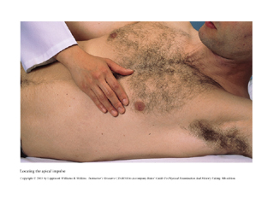
Assessing the PMI
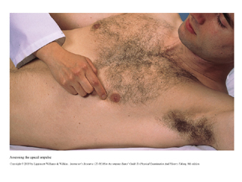

- Assess any anterior movement of the ventricle against the chest wall
- Normally the PMI is the point of maximal impulse BUT there are other conditions that can produce a prominent pulsation: Cor Pulmonale, dilated Pulmonary Artery, Aortic Aneurysm, Mitral regurgitation
- If the PMI is not palpable supinely, ask the pt to roll onto the left side—Left Lateral Decubitus position. You can ask the pt to EXHALE fully and hold for a few seconds if the PMI is still not palpable.
- Assess the PMI for its location, diameter, amplitude and duration
- Location: Vertical location = midclavicular line and horizontal location = ICS and distance from the left sternal boarder in cm
- Left sided displacement of the PMI = CHF
- Diameter: usually = 1-2.5cm

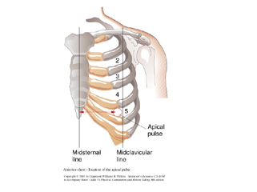
- Amplitude: usually brisk and tapping
- Hyperkinetic impulse or precordium = in anxiety state, emotional excitement, post exercise
- Hypokinetic impulse or precordium = dilated cardiomyopathy
- Duration: PMI lasts through the first 2/3 of systole—if the duration is longer—continues to the second sound—think VENTRICULAR HYPERTROPHY
- Precordial Areas to Palpate
- The pt is lying down @ a 30º angle
- Lower Left sternal boarder in the 3rd, 4th and 5th ICSs and subxiphoid area = Right Ventricle
- Left 2nd ICS = PA
- Right 2nd ICS = Aorta
- PERCUSSION
- Begin laterally and percuss medially in the 3rd, 4th and 5th ICS. Look for shift from resonance toward Cardiac Dullness

- AUSCULTATION
- Listen to all areas of the heart with the Diaphragm AND the Bell
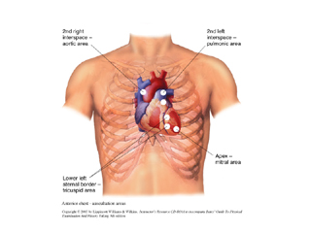

- Using the STETHOSCOPE
- The diaphragm: used for high pitched sounds—S1/S2, murmurs and pericardial FRICTION RUBS
  - Use the diaphragm to listen throughout the Precordium
  - Press the diaphragm firmly against the chest
- The bell: used for low-pitched sounds—S3/S4 and Mitral Stenosis
  - Use the Bell starting at the APEX (Mitral Area) and move medially along the sternal boarder
  - Press the bell lightly and listen to the entire precordium
  - S3/S4 may disappear if the bell is pressed too firmly against the chest. This may help identify these sounds
- Positions for Auscultation
  - Left Lateral Decubitus:
    - This position brings the left ventricle closer to the chest wall. Place the bell on the APICAL IMPULSE
    - This position is ideal for accentuating S3/S4 and the murmur of MITRAL STENOSIS

Left Lateral Decubitus Position
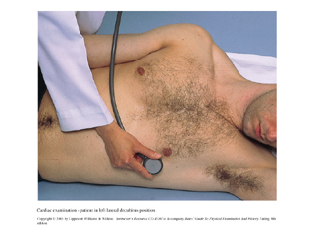
Another position to Exam the heart:
  - Sit up, Lean Forward, Exhale and Hold for a few seconds
    - Press the diaphragm along the Left sternal Boarder and APEX you may pause and ask the patient to breath momentarily
      - This position brings out Aortic murmurs
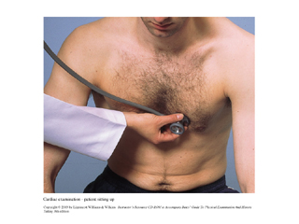
- Listening for HEART SOUNDS--AUSCULTATION
- In patients with thick chest walls, obesity or heart failure—Heart Sounds may sound distant
- First palpate either the CAROTID PULSE or the APICAL IMPULSE—these occur in early systole right after S1—to distinguish S1 from S2
- Note the INTENSITY of S1
- Is there any SPLITTING? Usually detected along the lower Left Sternal Boarder
- Note the INTENSITY of S2
- Is there any SPLITTING? Usually heard in the 2nd and 3rd LEFT ICS
- To hear S2 SPLITTING ask the patient to breath quietly but deeply.

- When in the RESPIRATORY CYCLE does it occur? Usually heard in INSPIRATION and should disappear with EXHALATION
- Listen for the A2 and P2 components of S2. A2 is usually louder

- HEART MURMURS—A Brief Introduction
- Review Events in the Cardiac Cycle: (P. 272) of Heart Sounds and Cardiac Cycle
- Are caused by TURBULENT blood flow
- Heart murmurs MUST be identified by the TIMING, SHAPE, LOCATION of MAXIMAL INTENSITY—grading, and QUALITY
- Timing: Decide whether a murmur is systolic vs. diastolic
- Feeling the CAROTID pulse can guide you with the timing. Carotid UPSTROKE occurs during SYSTOLE—S1
- Systolic murmurs can be further classified as:
- Midsystolic
- Pansystolic
- Late systolic
- Diastolic murmurs can also be classified as:
- Early diastolic
- Middiastolic
- Late diastolic
- Other systolic and diastolic murmurs:
- Continuous murmur: begin in systole and continue through or part of diastole
- Heard in Patent Ductus Arteriosus
- Pericardial Friction rubs also have diastolic and systolic components
- Pericardial Friction Rubs are enhanced with the patient sitting forward and with deep inspiration
- Shape
- Crescendo murmurs
- Decrescendo
- Crescendo-descrescendo
- Location of maximal Intensity
- Describe where on the chest wall is the murmur heard best in relation to the sternum, apex, midsternal, midclavicular or axillary lines
- Radiation or Transmission from the POINT OF MAXIMAL INTENSITY
- Detects the direction of blood flow from the site of the murmur’s origin along its path
- Intensity
- Usually graded on a 6-point scale and expressed as a fraction. The numerator indicates the intensity of the murmur’s sound and the denominator indicates the scale:

Grade: I/VI—barely audible with stethoscope

II/VI—slightly audible only with stethoscope

III/VI—clearly audible with stethoscope

IV/VI—loud murmur readily heard with stethoscope with palpable thrill

V/VI—Very loud with thrill—can be heard with stethoscope partially off the chest

VI/VI—Can be heard without the stethoscope

- Chest wall thickness and adjacent structures will affect the intensity
- Note that murmurs with an intensity equal or greater than 4 are accompanied by a THRILL
- Pitch
- Can be HIGH, MEDIUM, LOW
- Quality
- BLOWING, HARSH, RUMBLING, MUSICAL

- Listen at the TRICUSPID area with the BELL
- Listen at all other areas with the DIAPHRAGM

Table of MURMURS

Systolic Murmurs | Area Heard Best | Radiation | Patient Position | Clinical Features
Aortic Stenosis | Rt. 2nd ICS | Neck down to LSB | Sitting leaning forward
Pulmonic Stenosis | L 2nd 3rd ICS | L shoulder and neck |  | Congenital—often found in children
Mitral Regurgitation | Apex | L Axilla |  | Described as “blowing”
Tricuspid Regurgitation | Lower LSB | R Sternum
Ventricular Septal Defect | L 3rd 4th 5th ICS | Across entire chest
Diastolic Murmurs |  |  |  | Usually indicate heart disease
Aortic Regurgitation | 2nd →4th ICS | Apex | Sitting, leaning forward with breath in exhalation
Mitral Stenosis | Apex | NONE | L Lat. Decub. Pos
Systolic and Diastolic murmurs—Continuous
Patent Ductus Arteriosus | L 2nd ICS | L clavicle |  | Congenital,  Continuous murmur, harsh and machinery-like
Venous Hum | Medial 3rd of clavicle | 1st 2nd ICS |  | Humming or roaring murmur

Patterns of Systolic Murmurs
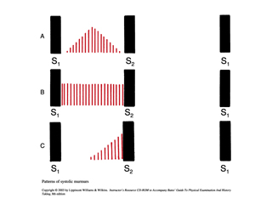

Patterns of Diastolic Murmurs
