HHPD PAC 06

The Neurological Examination

Central Nervous System

- Major regions of the CNS
- Brain
- Cerebrum: consists of four lobes
- Frontal
- Parietal
- Temporal
- Occipital
- Diencephalon: consists of two main areas
- Thalamus
- Hypothalamus

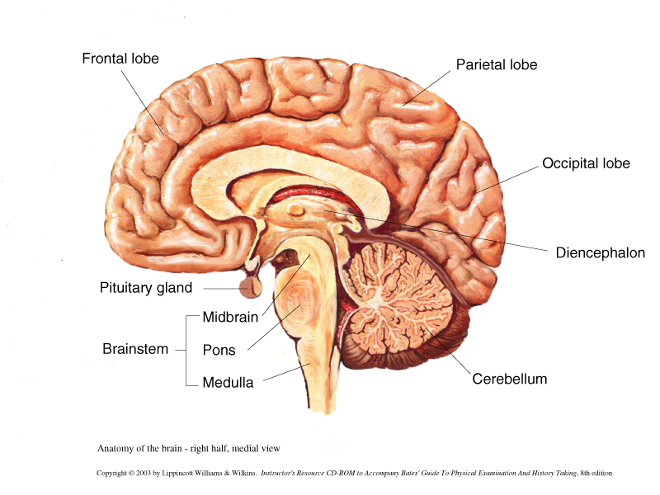

- Brainstem: consists of
- Medulla
- Pons
- Midbrain
- Cerebellum

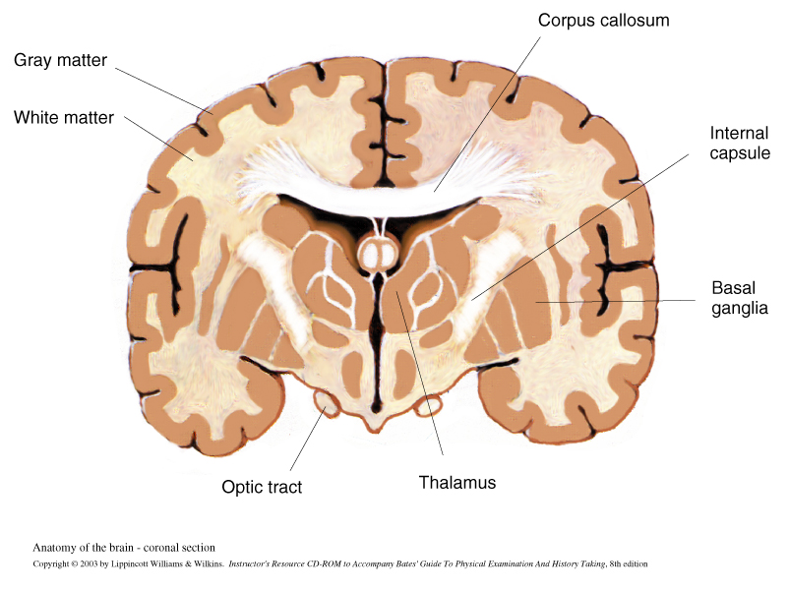

- Spinal Cord

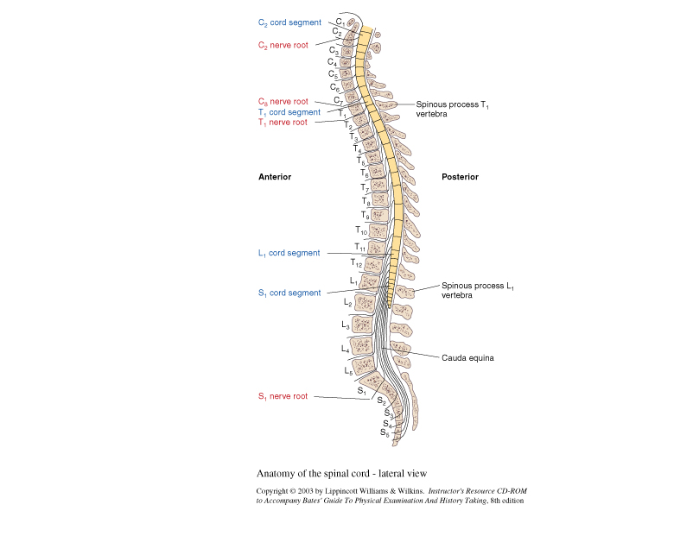

Selected Functions

- Cerebrum:
- Responsible for motor, sensory, associative, and higher mental functions (calculations, abstract thinking, reasoning, etc)
- Primary motor cortex –located in the Precentral gyrus, controls voluntary skeletal movements on the opposite side of the body
- Primary sensory cortex—located in the Postcentral gyrus, controls sensory perceptions, e.g., touch, pressure, pain—on the opposite side
- Primary visual cortex: receives visual stimuli and controls visual perception of the contralateral side
- Primary auditory cortex in the temporal lobe receives auditory stimuli

- Deeper masses of gray matter within the brain include:
- The basal ganglia: affects movement
- Also contains the Amygdala concerned with emotion
- Contains Extrapyramidal structures which are involved with the modulation of voluntary body movements
- Thalamus: processes sensory impulses and relays these to the cerebral cortex
- Hypothalamus: regulates temp, BP, HR, governs emotional behavior (anger and sexual drive), regulates pituitary function
- The brainstem:
- “Relay station” for all messages from the upper and lower levels of the CNS
- CNs III-XII arise from the brainstem
- Reticular activating (arousal) system—RAS
- Controls muscle stimulation that counteracts the force of gravity
- Is essential for the control of consciousness--sleep, coma (toxic metabolic vs structural)
- Medulla
- Contains the respiratory centers
- Midbrain
- Contains motor nuclei of CN III, IV
- Receives auditory stimuli from CN VIII
- The Pons
- CNs V, VI,VII, VIII nuclei are found in this area
- The Cerebellum
- Controls spatial perception of the individual, halting or checking movement—and helps keep body upright
- Controls fine hand movements

The Spinal Cord
- Contains sensory and motor nerve pathways that enter and exit the cord via nerve roots, spinal and peripheral nerves
- Mediates deep tendon reflexes
- Spinal Nerves—part of the Peripheral Nervous System
- Divided into five segments:
- Cervical (C1-8)
- Thoracic (T1-T12)
- Lumbar (L 1-5)
- Sacral (S1-5)
- Coccygeal (one coccygeal nerve)
- Important points
- The spinal cord is NOT as long as the vertebral column
- The lumbar and sacral roots travel the longest
- Cauda Equina
- The Spinal Cord contains both gray and white matter
- Gray matter: aggregation of nerve cell bodies
- White matter: white (axonal) tracts of nerve fibers connecting the CNS with the PNS
- Note: Lumbar punctures are performed at the L3-4 vertebral interspace

The Peripheral Nervous System

The Cranial Nerves

- CN III-XII arise from the brainstem
- CN I-II emerge from within deeper structures in the brain
- Some CNs have specialized functions: e.g., vision: II, Olfactory I, Auditory VIII
- Other CNs are limited to motor or sensory functions or both

Numerical Designation/Names of CNs and their Function
Number/Name | Function
CN I/Olfactory | Sense of Smell
CN II/Optic | Vision
CN III/Oculomotor | Extraocular movements, pupillary constriction, opening the eye
CN IV/Trochlear | Downward—inward movement of the eye
CN V/Trigeminal | Motor function: temporal, masseter muscles and lateral movements of the jaw  Sensory function: Ophthalmic, maxillary, mandibular
CN VI/Abducens | Lateral eye movement
CN VII/Facial | Motor: facial movements/expressions, closing the eyes and mouth  Sensory: taste—anterior 2/3 of the tongue
CN VIII/Acoustic | Hearing—cochlear division  Balance—vestibular division
CN IX/Glossopharyngeal | Motor: Pharynx  Sensory: taste—posterior 1/3 of the tongue, posterior portion of eardrum, canal and pharynx
CN X/Vagus | Motor: palate, pharynx, larynx  Sensory: pharynx, larynx
CN XI/Spinal Accessory | Motor: Sternocleidomastoid/trapezius
CN XII/Hypoglossal | Motor: Tongue

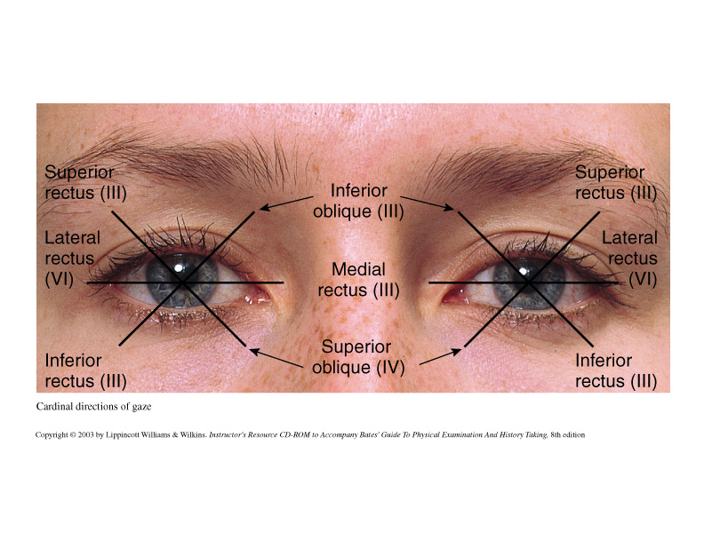

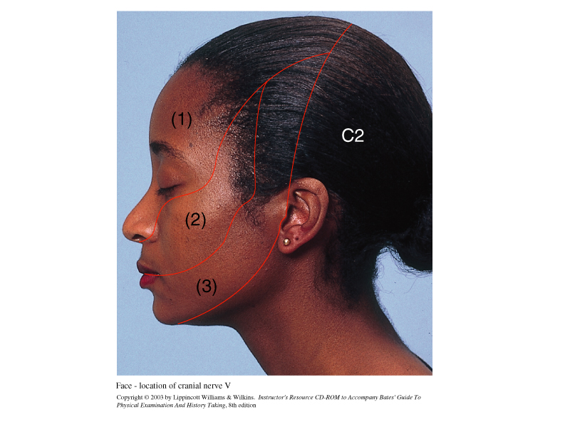
Trigeminal Nerve Divisions (CN V)—Sensory

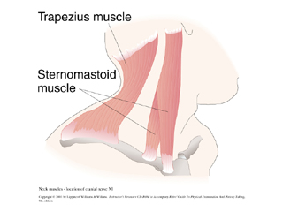CN XI Function

The Peripheral Nerves
- Nerves that carry impulses to and from the spinal cord
- Consists of 31 pairs of nerves attaches to the spinal cord
- Peripheral Nerve Structure
- Each has an anterior (ventral) root containing MOTOR fibers--efferent
- Each has a posterior (dorsal) root containing SENSORY fibers--afferent

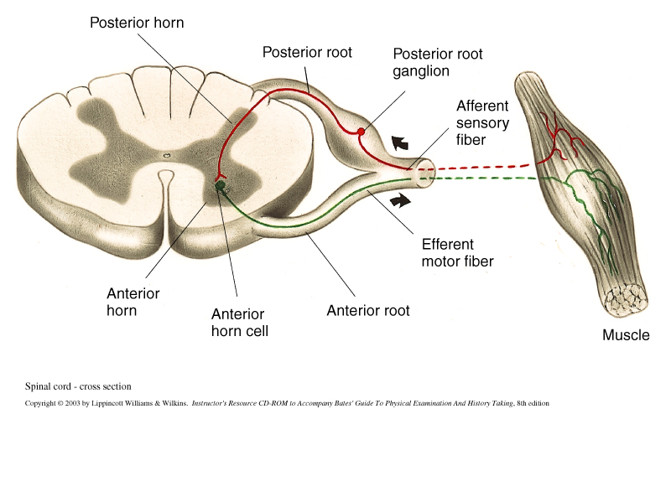

Spinal (Deep Tendon) Reflexes

- The action of striking a partially stretched muscle elicits a involuntary reflex response.
- The components to the reflex (aka:reflex arc)response include:
- The afferent or sensory nerve fiber
- The efferent or motor nerve fiber
- The spinal cord synapse
- Intact neuromuscular junction
- Intact muscle fibers
- Each DTR (deep tendon reflex) involves specific spinal segments as follows:

Reflex Response | Spinal Segment Involved
*Ankle reflex | S1
*Knee Reflex | L2,3,4
*Supinator Reflex (brachiolradialis) | C 5,6
*Biceps Reflex | C5,6
*Triceps Reflex | C6,7
Abdominal Reflexes  Upper:  Lower: | T8,9,10  T10,11, 12
Plantar Reflex | L5, S1

Motor Pathways

- Motor pathways control voluntary movement—connections from the cerebral cortex to the skeletal muscles are described using the concept of the Upper and Lower Motor Neurons

- The lower motor neuron and its axon supplies the terminating skeletal muscle

- Motor pathways contain motor neurons in the cerebral cortex and brainstem—their axons synapse in the brainstem (for CNs) and spinal cord (for peripheral nerves) with motor nuclei. Lower motor neurons have cell bodies in the spinal cord whose axons transmit impulses from the spinal nerves to the peripheral nerves and terminating at the neuromuscular junction

Principal Motor Pathways

- There are three pathways that connect via the anterior horn cells of the spinal cord:

- The Corticospinal (Pyramidal) Tract

- Mediates voluntary movement
- Integrates complicated or delicate movements by stimulating selected muscular movements and inhibiting others
- Motor fibers travel into the medulla where they cross to the contralateral side of the medulla continue downward where they synapse with the anterior horns in the spinal cord
- Tracts synapsing in the brainstem with motor nuclei of the CNs are called: Corticobulbar

- Damage to the Upper Motor Neurons of the Corticospinal or Extrapyramidal Tract:

- Upper motor neuron involvement above the crossover in the medulla motor impairment is seen on the contralateral side
- Muscular weakness or paralysis can result
- Skilled and complicated movements are poorly done when compared to gross movements
- Muscle tone is increased and DTRs are exaggerated

- Damage to the Lower Motor Neurons of the Corticospinal or Extrapyramidal Tract:

- Disease or damage below the crossover impairment is seen on the ipsilateral side
- Muscle tone and DTRs are absent or decreased

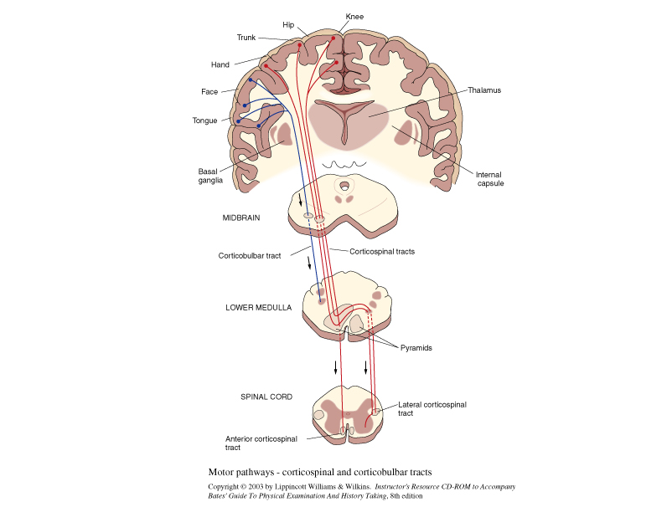

- The Basal Ganglia System

- Includes motor pathways between the cerebral cortex, basal ganglia, brainstem, and spinal cord.

- Helps to maintain muscle tone and control body movements such as walking

- Disease of the Basal Ganglia

- Increases muscle tone

- Bradykinesia and involuntary movements

- No paralysis

- The Cerebellar System

- The cerebellar receives sensory input from general and special senses (CN VIII) and has efferent connections with most of the CNS
- Primarily concerned with:

- Equilibrium

- Muscle tone and posture

- Timing and precision of muscle motor activity

- Diseases of the Cerebellar System

- Impairs coordination
- Impairs gait and equilibrium
- Decreases muscle tone

Sensory Pathways--Tracts

Sensory fibers registering sensations such as pain, temp, spatial position and touch pass through the PNs and posterior roots and enter the spinal cord—from there sensory impulses reach the sensory cortex in the brain via the:

- Spinothalamic Tracts
- Pain and temp sensations impulses pass into the posterior horn and synapse with a secondary neuron—these crossover and upwards to the spinaothalamic tract into the thalamus

- Posterior Columns
- Fibers registering sensations of position and vibration pass directly into the posterior columns of the spinal cord and travel upwards to the medulla and thalamus

- The SPT and the PC input continue from the thalamus and towards the sensory cortex in the cerebrum

- Diseases of the Sensory Tract

- Impairs fine discrimination, vibration and position sense, cannot identify an object by feeling it

- Loss of vibration and position sense with preservation of all other senses points to disease of the posterior column

- Spinal Cord Damage

- Loss of all sensation with paralysis and hyperactive reflexes from the waist down points to spinal cord transection
Dermatomes--below

- A dermatome is the band of skin innervated by the sensory root of a single spinal nerve
- Memorization of the location of most of the dermatones is essential —

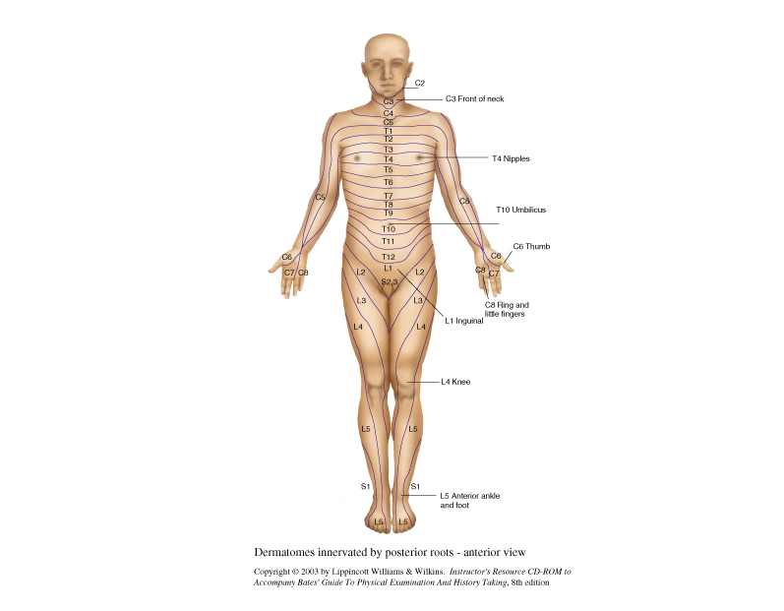

Know major landmarks—head, neck, arms, legs, areolar, umbilicus, pubic area, rectal, legs

Techniques of Examination

Overview of the Neurologic Exam: Five components to the neurological exam

- Mental status, speech and comprehension
- Cranial Nerves
- Motor system
- Sensory system
- Deep tendon reflexes (DTRs)

Three questions to ANSWER:

- Is the Mental Status intact?
- Is the neurological exam symmetrical?
- If there are abnormalities is the problem in the CNS/PNS

Mental Status/Speech/Language

- The MS exam begins with the General Survey

- Level of alertness
- Orientation
- Mood
- Attention
- Memory
- Insight/Judgement (unusual thoughts or perceptions)

- Components of the MS exam

- Appearance and Behavior
- Level of consciousness

- If the patient does not respond to verbal stimuli
- Call pt’s name in a loud (not screaming) voice
- Shake the pt GENTLY as if awakening a sleeper

2. Posture and Motor Behavior

- Is the pt. relaxed?
- Are movements voluntary or involuntary?
- Are certain parts immobile?

3. Dress, grooming and personal hygiene

4. Facial Expression

- Expressions of anxiety, depression, apathy
- Immobile facial muscles

5. Manner, affect, and relationship to persons and things

- Is the affect appropriate to topic being discussed?
- Is affect labile?
- Does the pt. reports visual or auditory hallucinations?

b. Speech and language

1. Quantity

- Talkative? Silent? Spontaneous? Only responds to questions?
- Fast vs. slow
- Loud vs. soft
- Articulation (dysarthria, aphasia)
- Testing for Aphasia (Wernicke’s vs. Broca’s)
- Word Comprehension
- Repetition
- Naming
- Reading Comprehension
- Writing
- Fluency
- Hesitancies
- Monotone
- Circumlocutions
- Paraphasias
c. Mood

- Ask the pt. “How are your spirits?”
- Any mood changes? or mood swings?
- If depression is suspected ask:
- Do you get discouraged?
- How do you see yourself in the future?
- Do you ever feel life is not worth living?
- Have you ever thought of doing away with yourself?
- How do you think you would do it?

d. Thought and Perceptions
- Thought processes—look for:
- Circumstantiality
- Derailment
- Flight of Ideas
- Neologisms
- Incoherence
- Confabulation
- Blocking
- Perseveration
- Echolalia
- Clanging

- Thought Content

- First ask the pt. who expresses paranoia or hallucinations:
“Can you tell me more about that”, “That must be very upsetting, have you ever experienced anything like this before?”

- Assess for:

- Compulsions
- Obsessions
- Phobias
- Anxieties
- Feelings of Unreality
- Feelings of Depersonalization
- Delusions

- Perceptions

- Ask: “When you hear voices what do they say? “How did it make you feel?
- Assess for:

- Illusions
- Hallucinations

- Insight and Judgment

- Ask: “What brings you to the hospital?”
- What do you think is wrong?”
- Assess judgment by noting a pt.’s response to family, health, financial, housing issues.
- Are decisions based on reality or impulsivity, or disordered thought content?
- Cognitive Function

- Orientation

- Incorporate into the interview dates, times, address, telephone number, family members’ names, route taken to the hospital
- Reassessing a delirious pt ask: “can you tell what time it is now?”
- Assess orientation to time, place and person

- Attention:
- Serial 7s
- Start from 100 and subtract 7
- Can use 3 instead of 7
- Count backwards is an alternative
- Spelling backwards
- Ask pt to spell a simple (5 letter) word
backwards
- Remote Memory:
- Recent Memory
- New Learning Ability

- Higher Cognitive Function
- Information and Vocabulary
- Calculating Ability
- Abstract Thinking
- Constructional Ability—Ask pt. to draw a clock with a time!

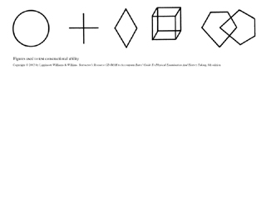

CRANIAL NERVES
Testing:

1. CN 1 (Olfactory)
- Compress one side of the nasal passage and ask the pt. to sniff (i.e., alcohol pad or soap)

2. CN II (Optic)

- Test visual acuity
- Inspect optic fundi with ophthalmoscope
- Visual fields by confrontation

3. CN III (Oculomotor)

- Test pupillary reaction to light and near response
- Inspect pupillary size and shape and compare symmetry

3,4, 6. CN III, IV, VI (Oculomotor, Trochlear, Abducens)

- Six Cardinal Direction of gaze
- Note nystagmus and direction of gaze in which it appears and plane of
movements
- Vertical, horizontal, rotary

5. CN V (Trigeminal)
- Motor
- Palpate temporal and Masseter muscles and ask pt. to clench teeth
- Move jaw sideways/laterally

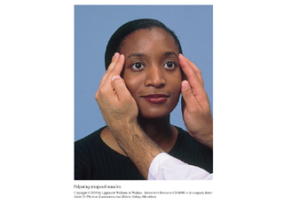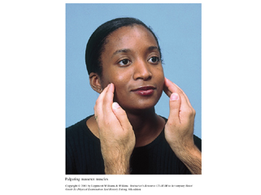

Temporal and masseter muscle assessment with pt clenching jaw

- Sensory
- Test for sharpness or dullness with a sharp/blunt object/ test for temperature/light touch on the three Trigeminal divisions

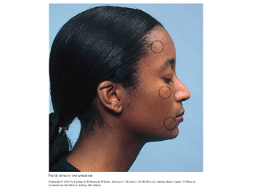Sensory testing areas for “sharpness or dullness”

Test the Corneal Reflex with a wisp of cotton

The result is blinking: CN V (sensory) and CN VII (motor)

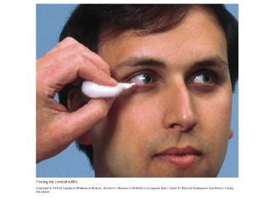

7. CN VII (Facial)
- Inspect the face for: asymmetry, tics
- Ask pt to (note weakness or asymmetry):
- Raise eyebrows
- To frown
- To close both eyes tightly and test strength
- To show both upper and lower teeth
- To smile
- To puff out both cheeks

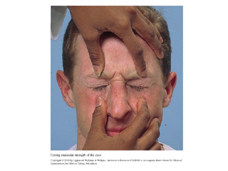

- CN VIII (Acoustic)

- Whisper Test—if there is hearing loss do:

- Rinne
- Weber

- and 10. CN IX, X (Glossopharyngeal and Vagus)

- Listen to the pt’s voice: hoarseness vs nasal quality
- Difficulty swallowing?
- Ask pt to say “ah” and watch movement of the soft palate, uvula pharynx
- Test the Gag Reflex

- CN XI (Spinal Accessory)

- Ask pt to shrug upwards against your hands—note strength
- Ask pt to turn head to each side against your hand—note strength

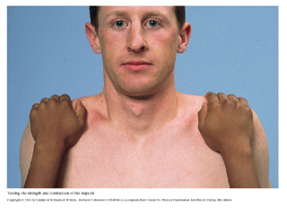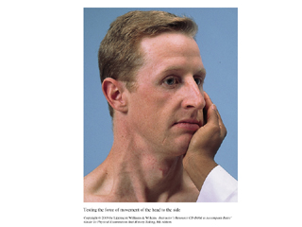

- CN XII (Hypoglossal)

- Inspect tongue as it lies on the floor of the mouth
- Look for fasciculations or atrophy
- Ask pt to stick out tongue and look for symmetry, deviation from midline
- Ask pt to move tongue from side to side

The Motor System
Overview: When approaching the motor system assess for:

- Body position
- Involuntary movements
- Muscle characteristics (bulk, tone, strength)
- Coordination
- If there an abnormality think about which nerve is involved, is it CNS vs PNS.

- Body Position

- Involuntary Movements

  - Tremors, tics, fasciculations
  - Note location, quality, rate, amplitude and relation to posture, activity, fatigue, emotion

- Muscle Bulk

  - Check for contour, size, atrophy, symmetry of findings
  - Atrophy: Check hands, shoulders, thighs
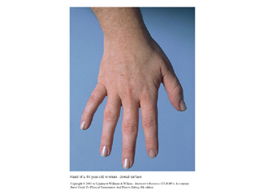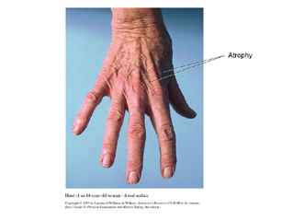
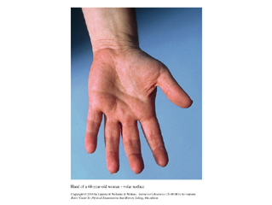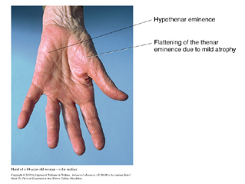

- Muscle Tone

  - When a muscle is relaxed it maintains a slight tension—this is known as muscle tone
- Support the pt’s elbow
- Take one hand and flex/extend the fingers, wrist, elbow, shoulder
- Note muscle tone on each side
- Note resistance to your movements
- Support the pt’s thigh with one hand
- Grasp the foot and flex/extend pt’s knee and ankle

- Muscle Strength
  - Strengths varies in age, sex, muscular training
  - Dominant side is usually stronger
  - Test strength:
    - Ask the pt to move against your resistance
    - Muscle strength grading scale:

0—No muscular contraction /flaccid paralysis
1—Barely detectable muscle contraction
2—Active movement of muscle BUT not against gravity
3—Active movement against gravity
4—Active movement against gravity and some resistance
5—Active movement against full resistance without evidence of fatigue—THIS IS NORMAL

You can add a + or – sign next to each number to indicate further distinctions within a grade level

Major Muscle Group Testing

Testing individual muscle groups can detect abnormalities in the spinal roots—PNS or CNS disease

Upper body

- Biceps
- Flexion /Extension C5, 6

- Triceps
- Flexion/ Extension C6, 7, 8

- Wrist
  - Flexion/extension C 6,7, 8 and Radial Nerve

- Have pt pull and push against your hand
- Grip test
  - C7, 8, T1
- Finger Abduction
  - C8, T1, Ulnar Nerve
- Opposition of the Thumb
  - C8, T1, Medial Nerve

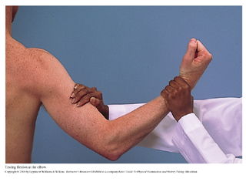

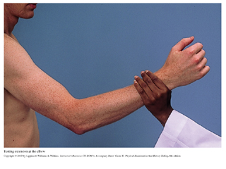

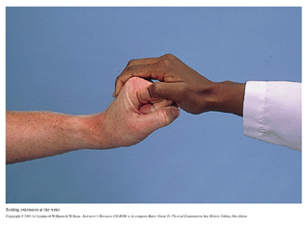

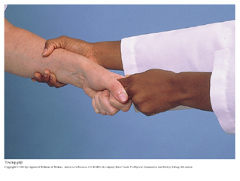

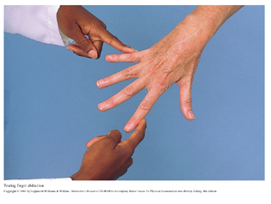

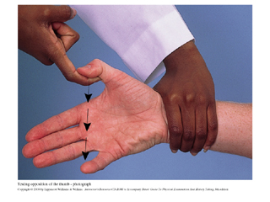

The Hip
- Test flexion
  - L2, 3,4—Iliopsoas
- Test adduction
  - L2, 3,4—adductors
- Test abduction
  - L4, 5, S1—gluteus medius and minimus
- Test extension
  - S1—gluteus maximus

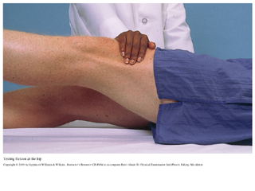Testing Flexion of the hip

The Knee

- Test Extension
  - L2, 3, 4—quadraceps
- Test Flexion
  - L4, 5, S1, 2—hamstrings

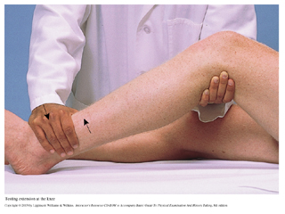Extension of the knee

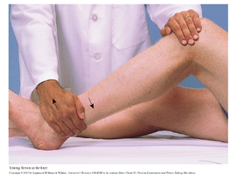Flexion of the knee

The Foot

- Test dorsiflexion
  - L4, 5
- Test plantar flexion--S1

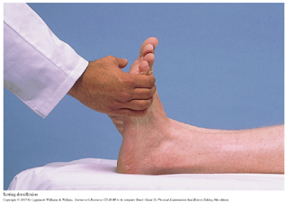Testing Dorsiflexion

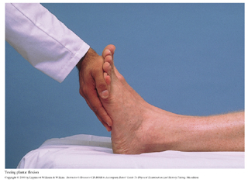Testing Plantar flexion

Coordination

Muscular coordination requires reciprocal input from:

- The motor system—muscular system
- The cerebellar system—rhythmic movement and steady posture
- The vestibular system—balance, coordination of eye, head and body movements
- The sensory system—Proprioception

The practitioner must note the following when assessing coordination:

- Rapid alternating movements (cerebellar)
  - Alternate hand—thigh
  - Index finger—thumb DIP
  - Dysdiadochokinesis
  - Ball of pt’s foot—examiner’s hand
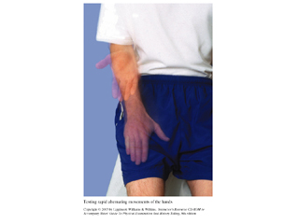Testing rapid alternating movements of the hand
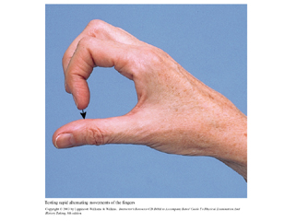Testing rapid alternating movements of the fingers

- Point-to-point Movements (labyrinth and cerebellar)
Arms:

  - Index finger to index finger—to pt’s nose
  - Pt raised arm then lower—examiner’s finger
  - Pt closes eyes and repeats b.
  - Dysmetria

Legs
  - Pt’s heel to knee—run down the shin to big toe
  - Repeat with eyes closed

- Gait (cerebellar)
  - Ask the pt to:
    - Walk across the room
    - Tandem walk (tandem walking)
    - Walk on toes/heels (distal muscular weakness/corticospinal tract disease)
    - Hop in place on each foot alternatively (cerebellar, proximal and distal muscles, cerebellar and proprioception)
    - Shallow knee bend (proximal weakness—hip extensors/quadricep weakness—knee extensors or both)
    - Raise from sitting position (more suitable for pt’s who cannot hop or bend knees)

- Stance

Stand close to the pt. When performing these maneuvers to prevent falling
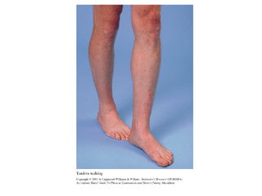Testing Tandem Walking

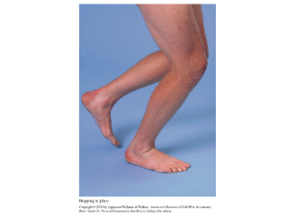Testing hoping in place

  - The Romberg Test
    - Mainly a test of POSITION SENSE
    - Ask pt to stand with feet close together with eyes open then close without support for 20-30 seconds
      - Pt has difficulty maintaining position with eyes closed in loss of POSITION SENSE—Positional Ataxia
      - Pt has difficulty standing with feet close together with eyes open in Cerebellar Ataxia

  - Test for Pronator Drift
    - Pt stands with arms extended and palms up for 20-30 seconds and with eyes CLOSED
      - Suggests a CONTRALATERAL lesion in Corticospinal Track if arms drift from center
    - Then TAP the arms briskly downwards the arms should return to their original position
      - Suggests intact muscular strength, coordination, and positional sense

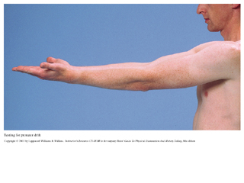Testing for Pronator Drift

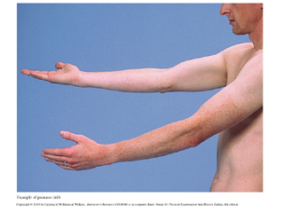Pronator drift illustrated

The Sensory System

Overview
Sensory system assessment includes:
- Pain and temperature (Spinothalamic tracts)
- Position and vibration (posterior columns)
- Light touch (both above)
- Discriminative sensations (both above and the cortex)

Patterns of testing
- Focus sensory exam where there are symptoms
- Determine whether motor or reflex abnormalities (spinal cord vs peripheral disease)
- Atrophic musculature or atrophic skin/ulceration
- Test for symmetry
  - Compare distal sensory findings with proximal extremity areas.
- Vibration and positional sensation
  - Test fingers and toes first—if normal proximal areas are also normal
- Vary your pattern of testing so that pt does not “guess” responses
- When detecting sensory loss or hypersensivity:
  - Map out its boundaries
  - Mapping out sensory abnormalities and type of sensations affected can help you locate the possible lesion

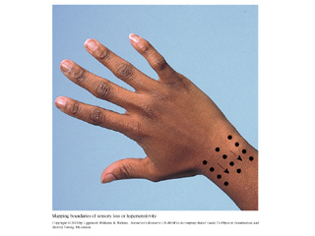Mapping out sensory deficits

- Patient should have eyes closed during this part of the neuro exam
- Show pt what you are going to do and the response you are interested in eliciting:
(“I am going to test your temperature sensation”, “tell if this feels cold or warm, sharp or dull”)

Testing Sensations

Pain
    - Test toes and fingers (dorsal or posterior surface)

Temperature
    - Usually omitted if PAIN is normal
    - Use tuning fork or test tubes

Light touch
    - Use cotton wisp
    - Avoid calloused skin

Vibration
    - Place tuning fork over DIP (distal interphalangeal joint) of finger then big toe
    - If vibration sense is impaired assess more PROXIMAL areas such as:
- Wrist
- Elbow
- Medial malleolus
- Patella
- Anterior superior iliac spine
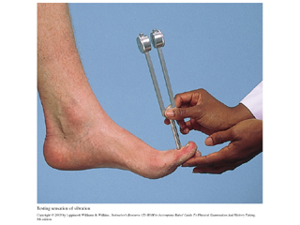Testing for vibratory sense of distal interphalangeal joint of index finger and great toe

Position
    - Grasp big toe and hold away from other toes
    - With pt’s eyes open demonstrate upward and downward
    - With pt’s eyes closed ask pt position of great toe as you move it up/down
    - If abnormal move PROXIMAL to METATARSOPHALANGEAL joints, ankle
    - Test fingers in same way
    - If abnormal move PROXIMAL to METACARPOPHALANGEAL joint, wrist, elbow
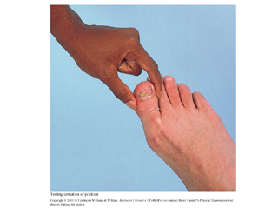Testing for position sense

Discriminative Sensation (Sensory Cortex)

    - Stereognosis

    - Graphesthesia (used when motor impairment prevents object identification)

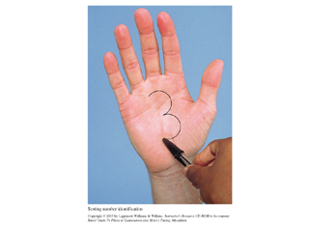Testing for graphesthesia

    - Two point discrimination
- Fingertips=2mm
- Tongue=1mm
- Toes=3-8mm
- Palms=8-12mm
- Back=40-60mm
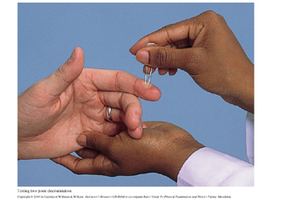Testing two-point discrimination

Point Localization (Sensory Cortex)

- With pt’s eyes closed touch pt on the skin—ask pt to open eyes and identify area touched

Extinction (Sensory Cortex)

- Touch corresponding areas at the same time and ask pt to identify where touched—both sides are felt
  - With sensory cortex lesions contralateral side is affected—stimulus is extinguished

Deep Tendon Reflexes (DTRs)

Patterns of testing

- Pt needs to be relaxed
- Symmetrically diminished or absent reflexes are found in NORMAL people
- Use REINFORCEMENT if reflexes are diminished

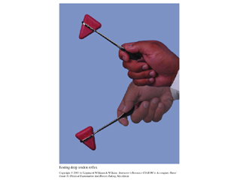Hand movement when testing reflexes

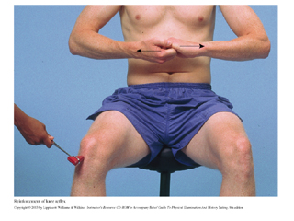Example of reflex REINFORCEMENT

  - Pull hand against the other, squeeze thigh with opposite hand
- Strike tendon briskly
- Pointed end of hammer is used for smaller areas
- Note symmetry, speed, force and amplitude of reflex response
- Reflex grading system

4+ very brisk, hyperactive, with clonus (CNS disease)
3+ Brisker than average
2+ Average, NORMAL
1+ Somewhat diminished, LOW NORMAL
0 No response (peripheral nerve, nerve root, muscle and neuromuscular junction damage)

Specific DTRs (sitting and lying down techniques)

- Biceps Reflex (C5, 6)
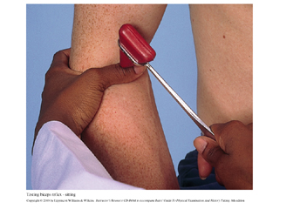Testing Biceps Reflex
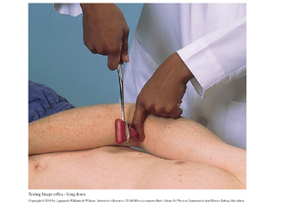Testing biceps reflex lying down

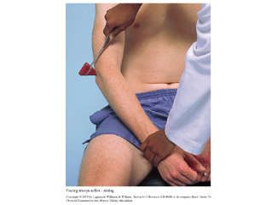Testing Triceps reflex

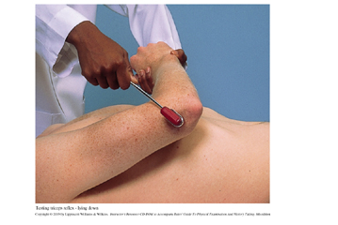Testing Triceps reflex lying down
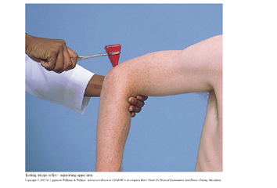Alternate method to test triceps reflex

- Triceps Reflex (C6, 7)
- Supinator or Brachioradialis Reflex (C5, 6)

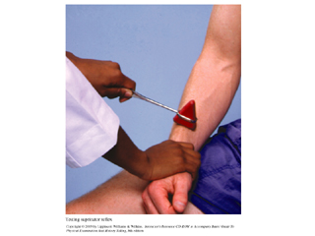Testing supinator reflex
- The Abdominal Reflexes
  - Above umbilicus (T8, 9,10)
  - Below umbilicus (T10, 11,12)
  - If pt is obese retract umbilicus away from side being tested and feel for muscular contraction with retracting finger.

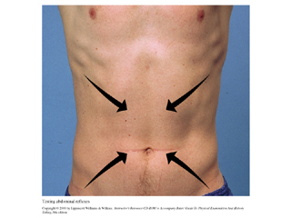Testing abdominal reflexes

- Knee Reflex (L2, 3,4)
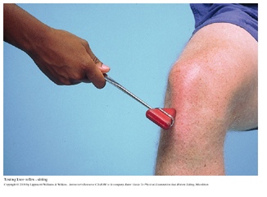Testing knee reflex
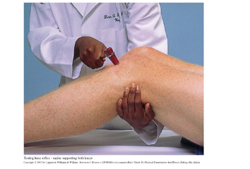Testing knee reflex with patient lying down

- The Ankle Reflex (S1)
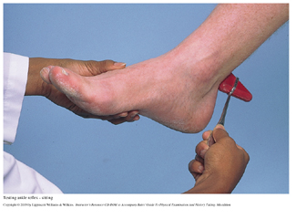Testing the ankle reflex

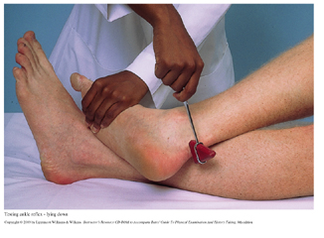Testing the ankle reflex with patient lying down

- The Plantar Response (L5, S1)—BABINSKY RESPONSE
  - With an object (end of hammer) stroke the LATERAL aspect of the sole from the HEEL to the BALL of the foot—curving medially across the ball
  - Use the slightest stimulus that will elicit a response
  - Use increasing firmness if necessary
  - Normal Response=toes FLEX and some pts will withdraw from the stimulus by flexing hip and knee
  - Abnormal Response=toes Extend with fanning of other toes=BABINSKI RESPONSE=Central lesion in the Corticospinal tract

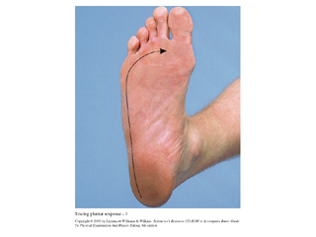Testing the Plantar response—BABINSKY
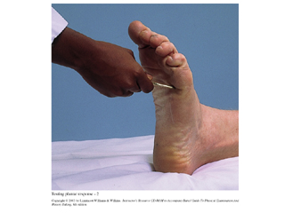Normal response—BABINSKY RESPONSE ABSENT
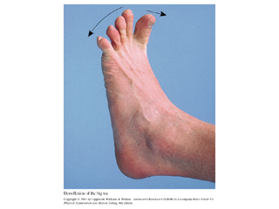Abnormal response—BABINSKY RESPONSE PRESENT—Upper Motor Neuron Deficit

- Clonus (CNS disease)
  - If reflexes are HYPERACTIVE test for CLONUS

- With knee flexed and the examiner supporting knee dorsiflex and plantar flex foot a few times
- Then sharply DORSIFLEX and maintain foot in this position
- Look and feel for oscillations between dorsiflexion and plantar flexion

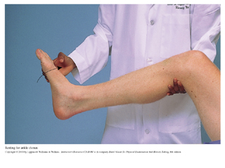Testing for ankle clonus—CNS disease

III. Special Techniques
- Asterixis

  - Helps to identify METABOLIC ENCEPHALOPATHY in patients who show mental status impairment
  - Ask pt to position hands as if to “STOP TRAFFIC” and wait for 1-2 minutes until flexion of hands and fingers is seen
- Meningeal Signs

- Crucial to test for these signs if MENINGITIS or SUBARACHNOID HEMORRHAGE is suspected
- Neck Mobility
  - Examiner flexes head forward UNTIL chin touches the chest
  - Neck should be supple
  - Resistance and pain is significant for meningeal inflammation
    - Can also be due to arthritis or neck injury

- BRUDZINSKI’s SIGN
  - Watch pt’s knee and hips as you flex the neck
  - Flexion of knee and hips is a POSITIVE Brudzinski and suggests meningeal inflammation

- KERNIG’s SIGN
  - Flex leg at knee and hip first then extend leg
  - Should not cause pain just discomfort
  - Pain is indicative of meningeal inflammation
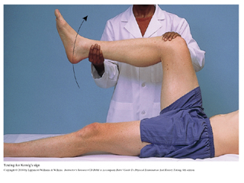Kernig’s sign for MENINGITIS

- Anal reflex (S2, 3,4)
  - Stroke outward all four quadrants and watch for contraction reflex
  - Loss of reflex seen in Cauda Equina lesion

Level of Consciousness
- Arousal techniques when assessing the stuporous patient
Level | Technique
Alertness | Speak to pt in a normal tone—pt responds appropriately
Lethargy  Obtundation | Speak to pt in loud voice—DO NOT SCREAM  Pt will respond but weakly—will respond to questions—then falls asleep again—not confused  Shake pt. Gently as if awakening a sleeper—pt will respond to you weakly and may be confused
Stupor  Coma | Apply a painful stimulus—rub the sternum—pinch a tendon—no stronger stimulus is needed—pt may be aroused from sleep but will return to sleep after painful stimulus is withdrawn—there is minimal awareness of self or environment  Apply repeated painful stimuli—pt will remain unarousable with eyes closed

Neurologic Evaluation of the Comatose Patient

- Respirations

  - Respiratory centers are in the cortex and brainstem and these overlap with neural connections that control consciousness

- Pupils

- Observe size and equality of pupil
- Test light reaction
  - Light reaction is intact in METABOLIC COMA
  - Light reaction is diminished in STRUCTURAL COMA

- Ocular Movement

- Oculocephalic Reflex (DOLL’S EYE)
  - Assesses BRAINSTEM function in a comatose patient
  - Turn pt’s head quickly from side to side (holding eyes open)
  - With intact brainstem eyes move toward the OPPOSITE side (DOLL’S EYE MOVEMENT)
  - Brainstem injury will show absence of doll’s eye movement

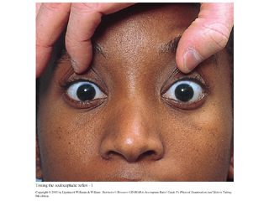Testing for oculocephalic reflex

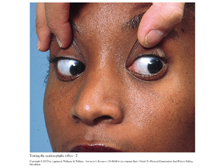In a patient with an intact brain stem eyes move opposite to head movement—AKA DOLL’S EYES

- Posture and Muscle Tone

- Observe pt’s posture
- If no spontaneous movement apply painful stimulus:
  - Aviodant = normal response
  - Stereotypic = painful response is followed by abnormal postural response of trunk and extremities
    - Decorticate rigidity
    - Decerebrate rigidity
  - Flaccid Paralysis
    - Raise forearm vertically then lower it about a foot from the bed and watch how it falls
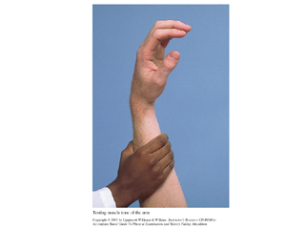Elevate patient’s arm and watch how it falls

      - Normally arm drops somewhat slowly
      - Flaccid hand forms a 90 degree angle with wrist
        - Flaccid hand/arm falls rapidly in HEMIPLEGIA
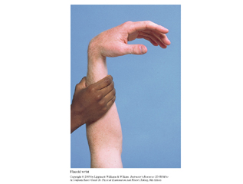Flaccid hand/arm falls rapidly—no muscle tone

Testing of lower extremities
      - Support pt’s flexed knees
        - Extend one leg at a time and let fall
          - Normal leg falls slowly to extended position
          - Flaccid leg falls rapidly in HEMIPLEGIA

IV. The Health History

- Patient concerns and symptoms

- Changes in mood, attention or speech
- Changes in orientation, memory, insight, or judgment
- Delirium or dementia
- Acute vs. Insidious
- Fluctuating vs. slowly progressive
- Hours to weeks vs. months to years
- Medical illness/drug toxicity vs. no med/drug toxicity
- Disturbed level of consciousness vs. normal LOC until late stage
- Disorganized thought vs. improvished thought content
- Disorientated vs. well maintained except in late stage
- Recent and immediate memory impairment vs. recent memory and new learning impaired
- Headache, dizziness, vertigo
- Descriptors for chief complaint and associated symptoms
  - Ask about assoc. symptoms, i.e., visual changes, weakness, loss of sensation, scotomas, affected by sneezing, coughing, head position (sinusitis, brain tumor), nausea, vomiting, neck pain, fever, hyperalgesia, nasal symptoms
- Generalized, proximal, or distal weakness
- Proximal
  - Ask if it is difficult to comb hair, reach for things, getting up from sitting position, taking a high step
- Distal
  - Ask about opening jars, cans hand tools, frequent tripping
- Numbness, abnormal or loss of sensations
- Paresthesias, dysesthesias
- Loss of consciousness, syncope, or near syncope
- Find out exactly what the pt. means by “fainted”
- Was there LOC?
- Could the pt. hear voices during the episode?
- Syncope (fainting) is a sudden LOC but temporary usually due to decrease blood flow to the brain
- Presyncope (near syncope, “feeling faint”, lightheaded, weak) is feeling faint but without LOC
- Seizures
- Did any one witness the event?
- What happened before, during and after the event? How was the pt. feeling during these phases of the seizure?
- Any LOC
- Any loss of bladder or bowel control?
- Any seizure-like movements?
- Impaired memory or headache after episode?
- Get medication history
- H/o head trauma
- Tremors or involuntary movements
- Resting tremors (Parkinson’s disease)
- Postural tremors (hyperthyroidism, anxiety, fatigue, familial)
- Intention tremors (absent at rest—worst with movement—cerebellar disease as in Multiple Sclerosis)
- Writing the neurological exam findings
Example:
“Mental status: pt is alert, cooperative and oriented to person, place and time. CN I not tested. Cranial nerves II-XII intact. Motor: good muscle bulk and tone. Strength 5/5 throughout. Cerebellar: RAM (F—N) (H—S) intact. Gait normal base. Rhomberg negative (maintains balance with eyes closed). No pronator drift. Sensory: Pain, light touch, position and vibration intact. Reflexes 2+ symmetric with negative Babinski bilaterally.”
Example:
“Mental status: pt is alert, initially uncooperative to questioning. Speech is slurred. Is A + O x 3. CN I not tested. CNs: II—visual intact; III, IV, VI—extraocular movements intact; right ptosis; V—motor—temporal and masseter intact; sensory—corneal reflexes intact; VII motor—bilateral facial movements intact; sensory—taste not tested; VIII—hearing intact to whispered voice; IX, X—gag reflex intact; XI—sternocleidomastoid and trapezius strength 5/5; XII—tongue midline. Motor: strength in right biceps, triceps, hamstrings, iliospsoas, gluteals, quadriceps, ankle extensor and flexor muscles 3/5 with atrophic bulk, with increased tone and spasticity; strength on right side 5/5 with good bulk and tone. Gait, rhomberg—unable to test due to right-sided weakness. Cerebellar on right unable to test due to weakness; left RAMs (F—N), (S—H) intact on left. Right pronator drift present. Sensory: decreased pain sensation over right face, arm and leg; intact on left. Decreased stereognosis and two-point discrimination on the right (palm, fingertips and infrascapular areas tested). Reflexes:

Swartz, p. 580
Swartz, p. 583
Basic Human Neuroanatomy, p. 44
ibid and Bates’ p. 541

