Surgical Tubes, Drains, & Catheters (pictures and answer key)
1. 1. 1.

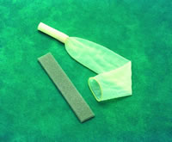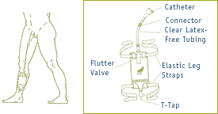

2. 3. 4.
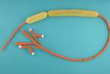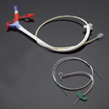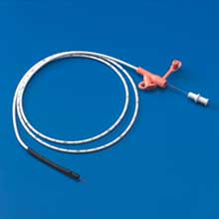

4. 5. 5.
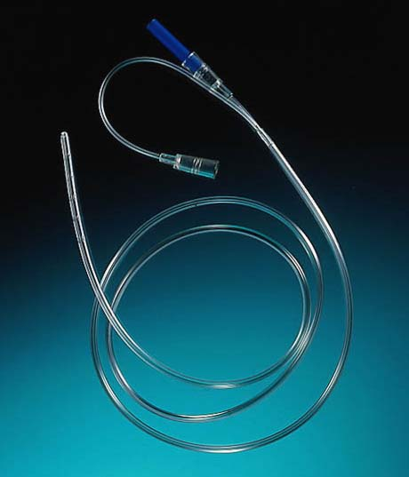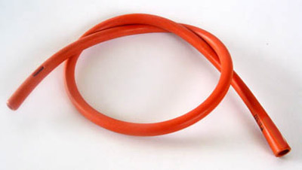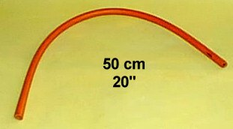

6. 6. 6.
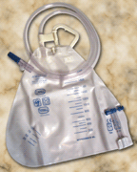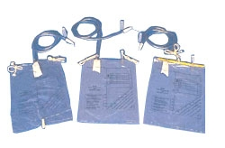

7. 7.

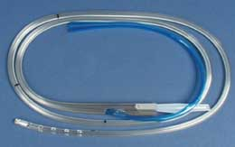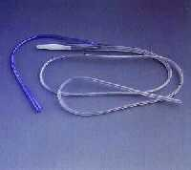

8.
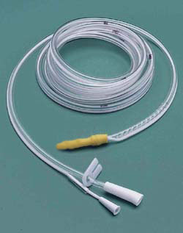
9.
9.
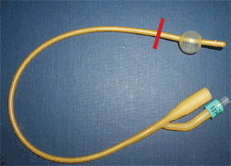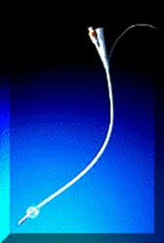

10. 10. (not just for humans!)
10.
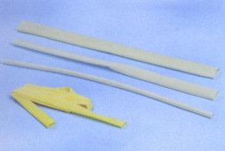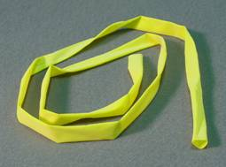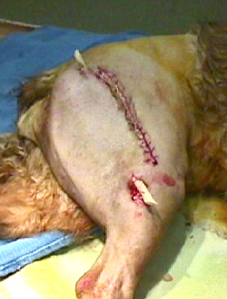

12.
11.
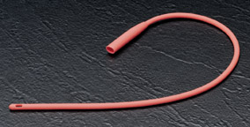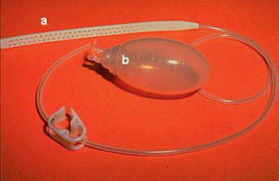

13. 13. (tip of drain magnified)

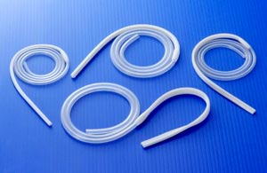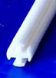

Answer Key

1. Texas (condom) style urinary catheter solo and with leg bag attachment.

2. (Sengstaken) Blakemore tube endotracheal tube used for balloon tamponade of
esophageal varices.

3. Feeding tubes.

4. Levine tube.

5. Rectal tube (used to release flatulence from rectum).

6. Urine collection bags.

7. Salem sump.

8. Intestinal bag with balloon (deflated) for mercury.

9. Foley catheter with balloon inflated and deflated.

10. Penrose drain (they’re NOT just for humans anymore!!!).

11. Red rubber catheter (straight catheter).

12. Jackson-Pratt drain.

13. Blake drain, with drain tip magnified.

