Mammography

A mammogram is a radiographic examination used to detect breast cancer in women. It is a technique that can rule cancer in, but cannot rule it out. It essentially is advantageous because it can detect cancers smaller than those that can be palpated on physical exam or self-examination, making screening an ideal process for older women. Although it can detect some cancers before they become palpable, it may not reveal some palpable cancers because they’re located in portions of the breast that are tough to image because their presence is masked by cystic or other changes in breast tissue. Note that once cancers become palpable upon examination, they are usually in a later stage than when they are initially discovered in mammography.

Although the process is painless, one other disadvantage is that it can at times be very uncomfortable for the patient. Patient risks basically involve the chance of false positives (25% in pts > 50 yo), potentially pregnant pts, and in addition involve the same radiation risks involved with similar x-ray imaging procedures (although radiation dose is higher than tradition procedures, overall risk is still low, and the benefit highly outweighs the risk).

There are two types of mammography examinations: screening and diagnostic. Screening is used on asymptomatic women to detect unsuspected breast cancer at an early stage. Diagnostic is performed to evaluate abnormal findings in the breasts such as palpable masses, nipple discharge, nipple retraction, skin thickening (focal or diffuse), trabecular thickening, skin lesions, axillary adenopathy, or architectural distortion.

Some indications for those that should seek mammography, along with breast ultrasound and other diagnostic imaging include women over 40, those with a family history of breast cancer, post-operative patients that have undergone surgery for breast cancer, African American women (have the highest death rate from breast cancer, followed by Hawaiians, and white non-Hispanic women), and finally those with abnormal findings on examination. Note that most insurance plans now cover the cost of screening for mammography for women over 40 years old.

Early detection is highly beneficial in speeding up treatment and recovery, and more importantly improving survival rate. Those with early onset of menses, late onset of menopause, nulliparity, and high levels of estrogen have all been found to be at a higher risk for breast cancer. In terms of hormonal influence, post menopausal HRT has been associated with higher incidence of breast cancer (the three subtypes: ductal, lobular, and tubular). Those with a PMHx of smoking have also been associated with a higher risk of breast cancer.

The most common type of breast cancer begins in the lining of the ducts and is called ductal carcinoma. Another type, called lobular carcinoma, is formed in the lobules.

If a woman detects any of the following changes on self-examination, she should seek medical evaluation immediately:

- A lump or thickening in or near the breast or in the underarm area
- A change in the size or shape of the breast
- A discharge from the nipple
- A change in the color or feel of the skin of the breast, areola, or nipple (dimpled, puckered, or scaly).

Needle aspiration can confirm the presence of a cystic mass. This differs from needle localization, which is used for women who have no symptoms (no “lump” is felt) but their screening mammograms show an abnormality that suggests cancer, and during a wide local excision (lumpectomy), if the breast is large but the tumor is small so the tumor cannot be felt. Another indication for localization is based on suspicion, but obstruction by normal calcification, so that the needle can bypass the obstacle and further evaluate the tissue.
When a nonpalpable lesion is seen on a mammogram, it can be localized by the radiologist for biopsy with mammographic or US guidance. Ct may be indicated in some as well. CT can show very posterior breast masses, close to the chest wall, that may be obscured in mammograms. MR is also useful in post-mammographic diagnostic.

A mammogram consists of two views of each breast: a mediolateral oblique (MLO – sideways view) view and a craniocaudal (CC – top to bottom view) view.
MLO View (Left to Right) CC View (Top-to Bottom)
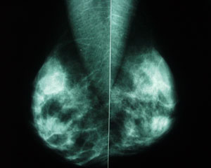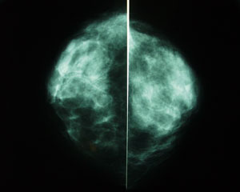

Examples of Mammography:
Normal Breast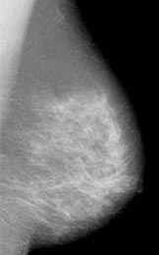 Tumor 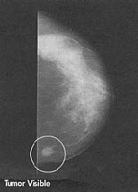

More Breast Cancer Images:

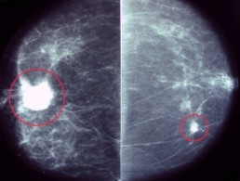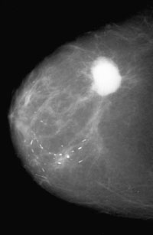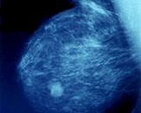

Interpretation of Mammograms
The quality of the mammograms should be assessed, and if not optimal, repeat examinations may be ordered. Mammograms of the right and left breasts are first placed back to back (mirror images) for comparable projections. Lighting should be homogenous, and adequate viewing conditions should be maintained. The mammograms are inspected carefully. The search is done systematically through similar areas in both breasts, comparing them all the times.
First, breast symmetry, size, general density, and glandular distribution are observed. Next, a search for masses, densities, calcifications, architectural distortions, and associated findings is performed. For masses, the shape, margins, and density are analyzed. Malignant lesions tend to be stellate masses and have irregular and (usually) spiculated margins. These malignancies, especially scirrhous cancers, also tend to have density greater than that of the normal breast tissue. Very low density, such as that of fat, is seen in benign lesions (eg, oil cyst, lipomas, galactoceles, hamartomas). If the cancer is close to the skin there may be skin retraction associated with it. They may be represented by clusters of microcalcifications, asymmetry of breast tissue, thickened skin, venous engorgement, and nipple retraction.
Benign Findings vs. Malignant Findings
 | Benign | Malignant
Size | Usually large | Usually small (< 0.5 mm)
Appearance | Coarse, often with smooth margins | Heterogenous shape, or fine granular, linear, branching (casting) shape
Easy to see? | Relatively, yes | Often, not
Benign Shape Classifications
Shape | Location
Eggshell | Cyst walls
Tramlike | Arterial walls
Popcorn | Fibroadenomas
Large, rodlike with possible branching | Ectatic ducts
Small calcification (with lucent center) | Skin
The lesion seen is located by using the views to either of the inner or outer or the lower or upper quadrants. It may also be central or retroareolar. The lesion can be described in a clock position. The breast is viewed as the face of a clock with the patient facing the observer. The depth of the lesion is assigned to anterior, middle, or posterior third of the breast.
If previous examination results are available, their comparison is useful in assessing disease progress.
Alternative Imaging Techniques
Ultrasound has become a valuable tool to use with mammography because it is widely available and less expensive than other options, such as MRI. Usually, breast ultrasound is used to target a specific area of concern found by the mammogram. Ultrasound also helps distinguish between cysts and solid masses and between benign and cancerous tumors. Ultrasound may be most helpful in women with high breast density (thickness). The National Cancer Institute (NCI) is sponsoring a clinical trial to evaluate the benefits and risks of adding screening breast ultrasound to screening mammograms in women with dense breasts and a higher risk of breast cancer. Its other advantages include real-time evaluation, as well as speed of procedure.
MRIs can be used to better examine cancers found by mammogram or for screening women who have a high risk of developing breast cancer. A few recent studies have shown that MRI screening for women at increased risk finds more cancers than standard mammography. However, it is not yet known if the difference between MRI and mammography in finding small cancers is great enough to save additional lives. And the MRI studies found many more abnormalities that were not cancers (high false-positives), which led to an increased number of biopsy procedures.
CT is usually not the first approach to be used in imaging breast cancer, but it may be used as an adjuvant for monitoring spread. Although it involves some exposure to radiation, it should be considered in patients in whom MRI is contraindicated. CT scan is also useful for helping detect lung and brain metastases and high axillary and intrathoracic lymphadenopathy. It could also be a pre-operative alternative to 3D MRI. In vitro high-resolution helical CT can depict the internal structure of small nodes. Morphologic changes detected on helical CT help distinguish benign from malignant nodes. Tumors appear as dense lesions on CT and usually show early contrast enhancement similar to that seen with dynamic MRI. CT is less sensitive than mammography for detecting microcalcification when it is the sole manifestation of early cancer. With contrast, CT scans can help specify lesions with high vascularity
Double reading is essentially a second independent radiological evaluation of a mammographic film after the initial assessment on the image is made. In the U.S., this practice is not primarily used, but Computer-Aided Detection is becoming more and more common and is proven to be a more efficient means of making a second mark on the films.
Note a couple of things: more often the not, the recommend screening age is issued at 35 years of age. Also, under 35 years of age, US is the initial procedure for investigation of palpable lesions. MRI is indicated for scarred breast, implants, multifocal lesions, and borderline lesions for breast conservation. PET Scan is useful in axilla assessment, scarred breast, and multifocal lesions. Scintimammography (with Tc 99m), while less sensitive than MRI for lesions smaller than 1 cm, is more specific for palpable lesions and is useful for detecting axillary involvement. Finally, despite the other methods, at this point in time, mammography remains as the only proven method that can detect minimal breast cancers.
Preparation (www.radiologyinfo.org):
Before scheduling a mammogram, the American Cancer Society (ACS) and other specialty organizations recommend that you discuss any new findings or problems in your breasts with your doctor. In addition, inform your doctor of any prior surgeries, hormone use, and family or personal history of breast cancer.
Do not schedule your mammogram for the week before your period if your breasts are usually tender during this time. The best time for a mammogram is one week following your period. Always inform your doctor or x-ray technologist if there is any possibility that you are pregnant.
The ACS also recommends you:
- Do not wear deodorant, talcum powder or lotion under your arms or on your breasts on the day of the exam. These can appear on the mammogram as calcium spots.
- Describe any breast symptoms or problems to the technologist performing the exam.
- If possible, obtain prior mammograms and make them available to the radiologist at the time of the current exam.
- Ask when your results will be available; do not assume the results are normal if you do not hear from your doctor or the mammography facility.
In addition, before the examination you will be asked to remove all jewelry and clothing above the waist and you will be given a gown or loose-fitting material that opens in the front.
Similarly, patient education involves monthly self-breast exams (SBE), associating the patient with the characteristics of abnormal findings, and avoiding risk factors such as smoking that may precipitate or initiate conditions favorable for developing cancer.

`

